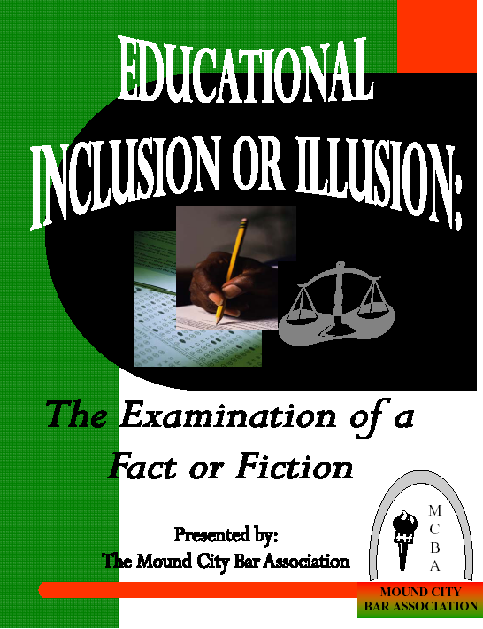

The General Body of the Mound City Bar Association has approved this report pursuant to the Association’s by-laws.

However, the views contained herein do not represent the official policy of any law firm or law school to which the Commissioners or MCBA members are affiliated.

Copyright 2006 Mound City Bar Association. All rights reserved.
EDUCATIONAL
Inclusion or Illusion:
The Examination of a Fact or Fiction


EDUCATION COMMISSION
CHAIR: William E. Dailey, Jr., Esq.

COMMISSIONERS:
Keisha I. Patrick, Esq.
Ebony M. Woods, Esq.
Professor Kimberly Norwood
Associate Professor Camille Nelson

ACKNOWLEDGMENTS

The Mound City Bar Association thanks the law students who participated in the Law Student Panel. Their willingness to take time away from the rigors of study to share their experiences were noted and appreciated by the body in attendance. We also thank the law students who participated in MCBA research in the form of interviews. Their experiences and thoughts are likewise appreciated.

In addition, the Young Lawyers Section of the MCBA provided marketing materials and sponsored the reception prior to the Panel. Their timely assistance greatly contributed to the success of the event.

Overall, we thank the law schools for their willingness to look at the realities underlying the pursuit of a more diverse legal academia.

Finally, we are indebted to you, the reader, for your sincere consideration and willingness to participate in this examination of diversity in Missouri law schools.

Report writers: William E. Dailey, Jr., Ebony M. Woods, and Keisha I. Patrick

Cover design by Jackalyn Olinger

Law Student Panel photographs courtesy of Donald Calloway, Jr.
Findings and Recommendations

TABLE OF CONTENTS

Foreword
MCBA President Pamela Meanes 2
Education Chair William E. Dailey, Jr. 3

Executive Summary 4

Commission Report 8
Washington University
Saint Louis University
University of Missouri – Columbia
University of Missouri – Kansas City

Recommendations 31

Addendum: 41
Survey Cover Letter

Education Commission Survey 47

Joint Response from the Deans of the Missouri law schools 54

Education Commission Response 56
Washington University Response
Saint Louis University Response
University of Missouri-Columbia Response
University of Missouri-Kansas City

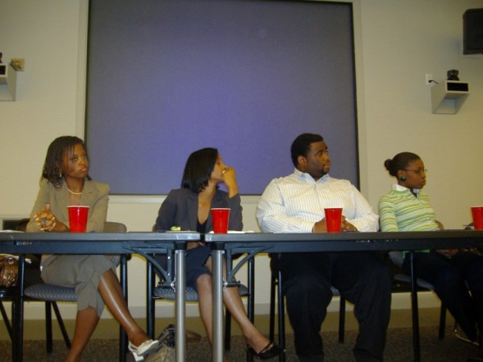
Seated left to right: Candace Parker, Sharhonda T. Shahid, Lionel Joiner, and Brenda Pacouloute at the MCBA Law Students Panel

Foreword
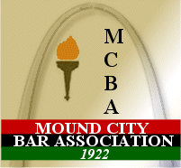

Mound City Bar Association President

Diversity is one of the most critical issues facing America and the legal profession today. To that end, rarely can one find an institution, business, or establishment which has not implemented a diversity initiative or program. Although most applaud these efforts, when confronted with their results, many have questioned whether said initiatives have created diversity or simply an appearance of it. Confronted with this critical question, in July 2006, the Mound City Bar Association (“MCBA”) decided to test the diversity initiatives of certain entities in the following four disciplines: 1) education, 2) social; 3) healthcare; and 4) employment. To accomplish this goal, a Commission was established for each discipline. Each Commission was charged with: 1) researching and surveying its particular entity; 2) conducting a panel discussion with the leaders of said entities at the MCBA general body meeting; and 3) drafting a Report which would be published in various media outlets.

In July 2006, the MCBA Education Commission, led by Chairman William Dailey, undertook the task of examining the diversity efforts of Washington University, St. Louis University, University of Missouri at Columbia and University of Missouri at Kansas City (collectively hereinafter “Missouri Law Schools”) to determine whether their initiatives have successfully led to the recruitment, retention, and preparation of future Black lawyers.

National trends seem to suggest that ABA approved law schools are losing the diversity battle. To that end, while most of these law schools have expressed a strong commitment to diversity, research reveals that in the past decade this commitment has not produced many results. For instance, while ABA-approved law schools have experienced an increase in overall enrollment and graduates, African-American law student enrollment and graduation has steadily declined since peaking in 1994 and 1998, respectfully. Even more alarming, the number of African-American applicants to ABA approved law schools for the September 2005 entering class dropped at nearly double the national rate.

This Report provides a critical analysis of the existing diversity efforts of the Missouri law schools and outlines findings and recommendations gathered from various sources. The motivating factor behind this Report arises from MCBA’s desire to formulate a collaborative partnership with these laws schools to: 1) reverse the historic decline of Black law school applicants; 2) improve the educational experience of Black law students; and 3) increase the number of qualified Black lawyers in the legal community.

I encourage MCBA, the Missouri law schools, and Black law students to utilize these findings and recommendations to enhance diversity in the legal profession.

2006-2007 MCBA President
Pamela J. Meanes
MCBA Education Commission Chair

…I’ve been trying to look through myself, and there’s a risk in it. I was never more hated than when I tried to be honest. Or when, even as just now, I’ve tried to articulate exactly what I felt to be the truth. No one was satisfied – not even I. On the other hand, I’ve never been more loved and appreciated than when I tried to “justify” and affirm someone’s mistaken beliefs; or when I’ve tried to give my friends the incorrect, absurd answers they wished to hear. In my presence they could talk and agree with themselves, the world was nailed down, and they loved it. They received a feeling of sincerity. But here was the rub: Too often, in order to justify them I had to take myself by the throat and choke myself until my eyes bulged and my tongue hung out and wagged like the door of an empty house in a high wind. Oh, yes, it made them happy and it made me sick. So I became ill of affirmation, of saying “yes” against the nay-saying of my stomach – not to mention my brain.

--Ralph Ellison, Invisible Man, 1952

In the following pages, you will find an honest attempt to examine diversity in Missouri law schools. This examination was entered to determine whether the diversity initiatives of the four Missouri law schools have successfully led to the recruitment, retention, and preparation of Black law students. It is the Education Commission's hope that you, the reader, and those charged with implementing the Commission's recommendations will receive this Report in the same spirit that guided our efforts. More importantly, I pray that our collective labors flow upon the same current of tenacity that motivated Civil-Rights-Era lawyers during a time when diversity was not merely an illusion, but was illegal. In spite of it all, they pressed forward towards change. I am optimistic that we will do the same.


Executive Summary

Inclusion or…

EXECUTIVE
SUMMARY

In its most basic sense, an illusion is something that deceives by producing a false or misleading impression of reality. Sometimes, an illusion is the unintentional consequence of nature whereby one is inspired by a mirage during moments of trial or distress. At other times, an illusion is the purposeful manipulation of people or activities to reflect a portrait of circumstances that do not exist. This latter incarnation of an illusion often greets Black law students at schools that champion student body diversity in brochures and on websites, but claim limitations when asked to make those promises real.

Conversely, inclusion is where a sincere appreciation for diversity is fostered at all levels of a law school experience. Students of color are not only engaged to participate in law school life, but their contributions are embraced and their relevance reiterated by meaningful exchanges with faculty and administration. More importantly, inclusive classrooms are not merely “aesthetically correct” to the eye. Instead, Black law students are systematically set-up to succeed by efforts that are responsive to the academic and social realities confronting students of color.

This study represents the first known effort to actively challenge the myth of inclusion in Missouri law schools. Of course, we did not begin with the presupposition that student body diversity at any law school was an illusion. Rather, in July 2006, the Mound City Bar Association (“MCBA”) set out to examine the diversity initiatives of Saint Louis University School of Law, Washington University School of Law, University of Missouri – Columbia School of Law, and University of Missouri – Kansas City School of Law (collectively, “the Missouri law schools”) to determine whether their initiatives have successfully led to the recruitment, retention, and preparation of future Black lawyers. From its inception, the Education Commission operated in a genuine spirit of partnership with the law schools evidenced by the Commission consisting solely of alumni, professors, and students of Saint Louis University, Washington University, and University of Missouri - Columbia Schools of Law. Notwithstanding, efforts at collecting data from the subject law schools were received with reservations and arguable suspicion.
Identifying the Issues

To accomplish its goal, the Education Commission employed a general process that Bar Associations have tried and tested in the past with much success. Simply stated, the Commission was charged with (1) researching national trends in recruitment, retention, and preparation at law schools; (2) drafting and distributing surveys to the Missouri law schools; (3) inviting the Deans of the Missouri law schools to a MCBA meeting for a discussion of survey results and to identify partnership opportunities; and (4) preparing a final report summarizing its findings and associated recommendations. In an effort to track the recruitment, retention, and preparation of an identifiable group, we limited our questions to the academic years 2002 – 2005. The General Body of the MCBA was made aware of each step and authorized the Survey and subsequent Panel.

In spite of the Education Commission’s transparent process and carefully worded Survey, the Commission’s request for information from the Missouri law schools was initially met with unanimous rejection. In a joint letter, the Deans shared their belief that “a conversation on these issues would be much more productive.” The letter continued by stating that much of the data, including the “racial breakdown of law school scholarships, research assistants, and moot court members is not collected” by the law schools. Moreover, the Deans asserted “to attempt to compile this and other data (such as the law school and bar examination performance of our students broken down by race) would run the risk of personally identifying individual students and possibly violate federal privacy laws.” Rather than respond with information that did not violate any privacy concerns, the Deans referred the Commission to data that is publicly available in the ABA-LSAC Official Guide to ABA Approved Law Schools. Conclusively, because of a scheduling conflict, the Deans were unable to participate in the MCBA Deans’ Panel and refused to respond to the Survey.

After failing to receive responses from all four Missouri law schools, the Education Commission submitted a second request for information. There, the Commission reiterated the cooperative and constructive spirit of the Survey and Deans’ Panel. More importantly, it emphasized the limited insight provided by research of national trends. To that end, it offered the law schools an opportunity to identify questions that may violate privacy concerns so that the Commission could remove them from the Survey. Because the Education Commission’s goal was to look beyond the numbers provided by NALP, at a minimum, it requested a statement describing the respective diversity initiatives or efforts the law schools employed in creating a diverse student body. If nothing more, a response to this second request would lessen the perception that the Missouri law schools were practicing an illusion. None of the Missouri law schools responded to our second letter.

The Law Student Panel
Equipped with student body diversity statistics provided by NALP, we hosted law students from Saint Louis University and Washington University Schools of Law for a discussion of diversity issues from the students’ perspective. Because of time and distance restraints, we were unable to include students from the University of Missouri law schools in Columbia and Kansas City. Nonetheless, what emerged from this candid conversation was both eye-opening and alarming. Recruitment initiatives were limited to undergraduate students. Retention endeavors were reactionary and not based on data available to the law schools at the time of admission. Preparation efforts were hindered by ineffective career services offerings. In total, the students described failures on all levels and offered a framework for many of the Commission’s ultimate recommendations.

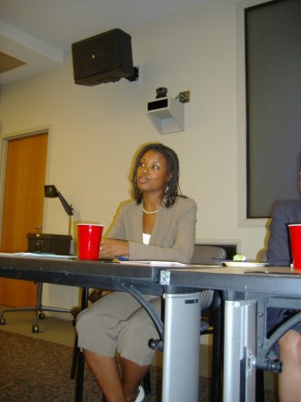

Confronting the Illusion

The American Association of Law Schools (“AALS”) sensibly notes that “diversity means more…than expanding access to those historically underrepresented and underserved by legal education and the legal profession. … It also implies changing the culture of educational institutions--making learning, the curriculum, and pedagogy more responsive to the needs of a changing student population and a changing world. ” Believing that a change is inevitable, this study seeks to assist the Missouri law schools in addressing perceptions and problems faced when attempting to promote diversity.

Commission
Findings and Results

Illusion?
COMMISSION FINDINGS
AND RESULTS

Diversity in Missouri Law Schools

Numbers do not speak for themselves. Or, at least, they should not in a profession built on the ability of individuals to communicate. Where numbers are left to the uninformed interpretation and potential bias of the reader, speculation results and solutions are lost in the confusion. Certainly, the Education Commission’s effort was not to mislead, demean, or maliciously critique the Missouri law schools, or any law school. Nonetheless, as a consequence of the position initially taken by the Deans of the Missouri law schools, we were unable to acquire targeted information regarding recruitment, retention, and preparation of Black law students. Accordingly, absent explanations for the numbers below, the reader is invited to draw his or her own conclusions from the information reported to the National Association for Law Placement (“NALP”).

2002-2003
 | Saint Louis University School of Law |  |  | Washington University School of Law |  |  | University of Missouri - Columbia School of Law |  |  | University of Missouri - Kansas City School of Law
 | Black | Total | % | Black | Total | % | Black | Total | % | Black | Total | %
Men (1L) | 4 | 159 | 2.5% | 7 | 116 | 6.0% | 2 | 96 | 2.1% | 2 | 104 | 1.9%
Women (1L) | 12 | 150 | 8.0% | 9 | 107 | 8.4% | 4 | 58 | 6.9% | 5 | 75 | 6.7%
Total 1L | 16 | 309 | 5.2% | 16 | 223 | 7.2% | 6 | 154 | 3.9% | 7 | 179 | 3.9%
Men (2L) | 4 | 110 | 3.6% | 4 | 154 | 2.6% | 5 | 110 | 4.5% | 1 | 85 | 1.2%
Women (2L) | 8 | 119 | 6.7% | 10 | 107 | 9.3% | 8 | 67 | 11.9% | 3 | 85 | 3.5%
Total 2L | 12 | 229 | 5.2% | 14 | 261 | 5.4% | 13 | 177 | 7.3% | 4 | 170 | 2.4%
Men (3L) | 5 | 114 | 4.4% | 4 | 145 | 2.8% | 2 | 120 | 1.7% | 3 | 73 | 4.1%
Women (3L) | 7 | 96 | 7.3% | 9 | 113 | 8.0% | 3 | 75 | 4.0% | 3 | 53 | 5.7%
Total 3L | 12 | 210 | 5.7% | 13 | 258 | 5.0% | 5 | 195 | 2.6% | 6 | 126 | 4.8%
Men (4L) | 3 | 24 | 12.5% | 0 | 0 | 0.0% | 0 | 0 | 0.0% | 0 | 0 | 0.0%
Women (4L) | 2 | 33 | 6.1% | 0 | 0 | 0.0% | 0 | 0 | 0.0% | 0 | 0 | 0.0%
Total 4L | 5 | 57 | 8.8% | 0 | 0 | 0.0% | 0 | 0 | 0.0% | 0 | 0 | 0.0%
TOTAL | 45 | 805 | 5.6% | 43 | 742 | 5.8% | 24 | 526 | 4.6% | 17 | 475 | 3.6%
2003-2004
 | Saint Louis University School of Law |  |  | Washington University School of Law |  |  | University of Missouri - Columbia School of Law |  |  | University of Missouri - Kansas City School of Law
 | Black | Total | % | Black | Total | % | Black | Total | % | Black | Total | %
Men (1L) | 4 | 145 | 2.8% | 7 | 138 | 5.1% | 1 | 89 | 1.1% | 1 | 84 | 1.2%
Women (1L) | 9 | 146 | 6.2% | 7 | 99 | 7.1% | 4 | 67 | 6.0% | 1 | 74 | 1.4%
Total 1L | 13 | 291 | 4.5% | 14 | 237 | 5.9% | 5 | 156 | 3.2% | 2 | 158 | 1.3%
Men (2L) | 5 | 131 | 3.8% | 6 | 142 | 4.2% | 2 | 90 | 2.2% | 2 | 89 | 2.2%
Women (2L) | 11 | 142 | 7.7% | 10 | 114 | 8.8% | 4 | 52 | 7.7% | 5 | 90 | 5.6%
Total 2L | 16 | 273 | 5.9% | 16 | 256 | 6.3% | 6 | 142 | 4.2% | 7 | 179 | 3.9%
Men (3L) | 5 | 101 | 5.0% | 5 | 143 | 3.5% | 5 | 120 | 4.2% | 2 | 85 | 2.4%
Women (3L) | 7 | 108 | 6.5% | 9 | 106 | 8.5% | 4 | 69 | 5.8% | 2 | 76 | 2.6%
Total 3L | 12 | 209 | 5.7% | 14 | 249 | 5.6% | 9 | 189 | 4.8% | 4 | 161 | 2.5%
Men (4L) | 3 | 28 | 10.7% | 0 | 0 | 0.0% | 0 | 0 | 0.0% | 0 | 0 | 0.0%
Women (4L) | 0 | 24 | 0.0% | 0 | 0 | 0.0% | 0 | 0 | 0.0% | 0 | 0 | 0.0%
Total 4L | 3 | 52 | 5.8% | 0 | 0 | 0.0% | 0 | 0 | 0.0% | 0 | 0 | 0.0%
TOTAL | 44 | 825 | 5.3% | 44 | 742 | 5.9% | 20 | 487 | 4.1% | 13 | 498 | 2.6%
2004-2005
 | Saint Louis University School of Law |  |  | Washington University School of Law |  |  | University of Missouri - Columbia School of Law |  |  | University of Missouri - Kansas City School of Law
 | Black | Total | % | Black | Total | % | Black | Total | % | Black | Total | %
Men (1L) | 1 | 140 | 0.7% | 6 | 147 | 4.1% | 6 | 88 | 6.8% | 3 | 123 | 2.4%
Women (1L) | 7 | 163 | 4.3% | 9 | 91 | 9.9% | 5 | 57 | 8.8% | 2 | 88 | 2.3%
Total 1L | 8 | 303 | 2.6% | 15 | 238 | 6.3% | 11 | 145 | 7.6% | 5 | 211 | 2.4%
Men (2L) | 3 | 136 | 2.2% | 8 | 159 | 5.0% | 1 | 88 | 1.1% | 0 | 70 | 0.0%
Women (2L) | 7 | 135 | 5.2% | 7 | 109 | 6.4% | 4 | 64 | 6.3% | 4 | 70 | 5.7%
Total 2L | 10 | 271 | 3.7% | 15 | 268 | 5.6% | 5 | 152 | 3.3% | 4 | 140 | 2.9%
Men (3L) | 6 | 127 | 4.7% | 7 | 135 | 5.2% | 5 | 89 | 5.6% | 1 | 84 | 1.2%
Women (3L) | 11 | 125 | 8.8% | 10 | 115 | 8.7% | 3 | 51 | 5.9% | 5 | 93 | 5.4%
Total 3L | 17 | 252 | 6.7% | 17 | 250 | 6.8% | 8 | 140 | 5.7% | 6 | 177 | 3.4%
Men (4L) | 1 | 23 | 4.3% | 0 | 0 | 0.0% | 0 | 0 | 0.0% | 0 | 0 | 0.0%
Women (4L) | 0 | 24 | 0.0% | 0 | 0 | 0.0% | 0 | 0 | 0.0% | 0 | 0 | 0.0%
Total 4L | 1 | 47 | 2.1% | 0 | 0 | 0.0% | 0 | 0 | 0.0% | 0 | 0 | 0.0%
TOTAL | 36 | 873 | 4.1% | 47 | 756 | 6.2% | 24 | 437 | 5.5% | 15 | 528 | 2.8%

Source: NALP Directory of Law Schools

Source: NALP Directory of Law Schools

Diversity Deferred

Each of the Missouri law schools profess a commitment to diversity. The Education Commission recognizes that their diversity initiatives are not limited to the areas of the Commission's focus – Black law students. Therefore, the Commission hesitates to make a conclusion on the overall success of each school's diversity efforts. Nonetheless, questions remain regarding the effectiveness of the four law schools' efforts and willingness to critically assess the current state of diversity, specifically in regard to Black students. Below is a school-by-school evaluation of diversity efforts across the state.


Washington University
School of Law

Inclusion…

Of the four schools studied, Washington University School of Law (“WashU Law”) was the most responsive. After meeting with MCBA President Pamela Meanes, the Dean provided a detailed letter outlining the diversity initiatives at the Law School. Further, quantitative data was provided in response to select questions. Below are highlights from the Dean’s letter and associated research:

Recruitment Understanding the significance of reaching out to the minority students early on, the Law School participates in programs that identify outstanding minority high school students and college undergraduates, and encourages them to study law. Two programs in particular, are hosted on an annual basis. The first program is the St. Louis Intern Group Law Day. As part of the Law School Admissions Council’s (LSAC) National Minority Law Student Recruitment month, each year in February we host minority high school students for a half day program at our school. (The St. Louis Intern group was created several years ago to provide minority high school age students from the city of St. Louis with an opportunity to work in law offices and to be exposed to the practice of law as a career option.)

In addition, we participate in a University sponsored program called Target Hope which brings to campus each June a group of minority college students who are interested in pursuing an advanced degree at a graduate or professional school.

Other recruitment efforts include participation at the seven national Law School Forums hosted by the Law School Admissions Council, (which traditionally have large numbers of minority law school candidates in attendance) and recruitment at law school and graduate school fairs at colleges and programs with substantial numbers of minority students (including Historically Black Colleges and Universities), minority recruitment fairs, and financial support and participation each year in CLEO.

Another effort to reach minority candidates who might not otherwise apply to our Law School, is our use of the LSAC’s Candidate Referral Service. Database searches for African American candidates are conducted after each LSAT testing date to identify those candidates whose records indicate that they might qualify for admissions to our program. Application fee waivers are also granted to these candidates.

Admission The Law School has sought to model its approach to racial diversity after Justice Powell’s opinion in Bakke. The hallmark of that approach is individualized consideration of each candidate, with attention paid to a wide variety of attributes, including race, that may be relevant to an applicant’s success at the Law School and/or contribution to the class. In Grutter and Gratz, the Supreme Court affirmed that this individualized consideration is a necessary aspect of any admissions policy that considers race.

The Law School’s approach to minority admission resembles that approved by the Supreme Court. The ultimate number of minorities enrolled (as well as the racial or ethnic composition within the minority group) has not been monitored on a daily basis at Washington University, and has never been mandated by any target number or articulated “critical mass”, but rather has been the natural result of the applicant pool and the individual judgment of the people making admissions decisions each year. As a result, the numbers of specific minority groups represented in the student body have varied over the years.

Financial Aid All African American students receive financial aid in the form of both merit and need based scholarship funding. These scholarships range in amounts from $2,000 to full tuition scholarships with stipends (i.e. the Walter Moran Farmer Scholarship and the Chancellor’s Graduate Fellowship). In addition, the school of Law participates each year in the ABA’s Legal Opportunity Scholarship Fund.

Career Services Washington University minority students attend five job fairs focused on racial diversity: St. Louis Minority Clerkship Program, Cook County Minority Job Fair, Midwest Minority Recruitment Conference, Northwest Minority Job Fair, and the Minnesota Minority Recruitment Conference.

Academic Performance and Bar Exam Preparation A number of minority students have excelled academically at our Law School and have served on the staff and boars of the school’s law journals and trial teams. Academic support is provided to all of our students and focuses on briefing and note-taking, outlining, and exam-taking. In addition, a Supplement Bar Program is conducted for the February and July Bar Exams which consist of time management sessions and lessons on essay writing and multiple choice exam takings skills. Historically, Washington University has had some of the highest bar passages rates for the state of Missouri.

Law Student Diversity
Year | Total Students | American Indian | Asian Pacific Islander | Black/African American | Mexican American | Puerto Rican | Hispanic | Total Number  of Minority
2005 | 745 | 4 | 67 | 48 | 3 | 0 | 6 | 128
2004 | 742 | 7 | 65 | 43 | 1 | 1 | 7 | 124
2003 | 704 | 6 | 68 | 38 | 2 | 0 | 4 | 118

Law Faculty Diversity
Year | Total Faculty Fall | Total Faculty Spring | Total Number Minority Fall | Total Number Minority Spring | Total Part-time Minority Faculty Fall | Total Part-time Minority Faculty Spring
2005 | 46 | 47 | 5 | 4 | 11 | 5
2004 | 43 | 43 | 4 | 4 | 7 | 5
2003 | 42 | 40 | 5 | 2 | 5 | 4

Law Review Participation
Year | Global Studies Law Review AFAM | Global Studies Law Review | Law Quarterly/  Law Review AFAM | Law Quarterly/  Law Review | Journal of Law and Policy AFAM | Journal of Law and Policy | Total AFAM | Total Non-AFAM
2004 | 4 | 72 | 2 | 88 | 1 | 67 | 7 | 227
2005 | 7 | 66 | 3 | 97 | 2 | 71 | 12 | 234
2006 | 6 | 70 | 2 | 93 | 4 | 88 | 12 | 251

Moot Court Participation
Year | African Americans  Moot Court | African Americans Research Assistants (TAs & Supervised Research)
2004 | 6 | 1
2005 | 6 | 5
2006 | 2 | 4

Financial Aid
Year | Total First Year African American Scholarship Amounts
2004 | $340,950
2005 | $238,600
2006 | $332,680

or Illusion

The law students’ perspective at WashU Law reflected a varied response on several points. Issues identified by current students and alumni are as follows:

- The Law School Hiring Committee routinely interviews and rejects Black candidates for teaching positions. This minimizes the potential influence and impact that a more diverse faculty would have on mentoring and/or assisting Black law students succeed.

- An exclusive emphasis on minority job fairs in lieu of on campus interviewing results in exposure to fewer opportunities for employment following graduation.

- Recruiting efforts focus on only a limited number of Historically Black Colleges and Universities thereby missing out on highly qualified candidates that matriculate therein.

- Reportedly, the class of 1976 included 16 Black law students. Similarly, the class of 2007 includes 16 Black students.

Source: NALP Directory of Law Schools


Saint Louis
University School
of Law

Inclusion…

Following a lunch meeting with MCBA President Meanes, the Dean of Saint Louis University School of Law (“SLU Law”) provided insight on diversity initiatives currently taking place at the Law School. The information did not address the years of the study; however, it does provide a picture of diversity issues and opportunities from the Dean’s perspective. The Dean’s remarks are as follows:

Recruitment
- Our recruiting efforts are extensive and similar to those of law schools in general. Those efforts include every medium and technique, including visiting campuses of our traditional feeder schools and a number of historically black colleges. Competition for qualified minority students is especially intense. We are, of course, subject to national trends. It was reported in the July 2006 Newsletter of the Law School Admissions Council that “African American applicants to law schools in 2005 declined by 668, or 6.3%, from Fall 2004, and the number of matriculants declined by 126, or 4.1%, between 2004 and 2005.” Our minority enrollment has remained fairly stable despite the national trends.

- One important aspect of our effort to reach out to disadvantaged students and others who have historically not been well represented in law schools is our Summer Institute. For many years the Admissions Committee has selected several dozen applicants whose academic credentials are marginal, but whose file suggests promise and whose presence in the student body would produce greater diversity. Those applicants are invited to attend the Summer Institute, free of any charge, for a seven week program of instruction taught by two members of the faculty. The program includes a research and writing course and a substantive law course, both of which conclude with examinations. This Fall eleven Summer Institute students are enrolled in the first year class.

- The Fall 2006 entering class was composed of 39 minority students who constitute 11.4% of the entering class. They are the most academically talented class of minority students ever to matriculate at the Law School, with a median LSAT score of 154 and a mean UGPA of 3.25. The composition of the class includes 1 American Indian, 12 Asian Americans, 18 African Americans, 1 Mexican American, 6 Hispanics, and 1 Pacific Islander. This composition, again, varies from year to year.

- We have instituted two outreach efforts with a long term view of increasing the local pool of qualified minority candidates with an interest in obtaining a legal education. Both efforts involve the St. Louis City schools.

- We have a new Assistant Director of Admissions who is also especially focused on the recruitment of minority students.

Retention/Preparation
- Minority student enrollment at Saint Louis University School of Law has averaged 92 students over the last five years, though the numbers vary from year to year as the Admissions Committee makes careful and individuated decisions in review of several thousand files. This academic year we have 99 minority students enrolled in the School of Law.

- Over the years we have taken steps to provide academic assistance to any members of the student body who are at academic risk. We have a full-time Director of Academic Advising, a half-time Writing Specialist, and a Legal Methods course in which second semester students whose first semester performance was sub par must enroll. While these resources/programs are available to the entire student body, they have been especially useful in providing support for our minority students.

- We have also recently taken significant steps to enhance our efforts to increase the diversity of our student body and to achieve an enhanced nurturing and encouraging environment. The position of Director of Multi-Cultural Affairs was created last year and is currently held by a 1994 graduate of the University of Chicago Law School. Finally, this Fall we have implemented the “Saturday School Program”; it is based on the successful Harvard Law School program of the same name and consists of three components: Speakers Series; Study Series; and Career Series. It is targeted especially for our minority students.

- The Saint Louis faculty is more diverse than ever before. The full time faculty of 51 this academic year includes 29 males and 22 females and 6 faculty members of color. We believe there is an important synergy between our success in achieving a more diverse faculty and our efforts to recruit a more diverse student body. Overall, the more diverse our community, the more enriched is our academic environment.
or Illusion?

In contrast to the above assessment, several issues were uncovered during the Law Students’ Panel and our independent research.

- Students matriculating in the Summer Institute traditionally have lower LSAT scores and/or undergraduate GPAs. Notwithstanding, the Law School does not require any directed academic assistance to ensure that these students thrive in the classroom.

- Scholarships from the Law School are reserved for admitted students and awarded on a first come first serve basis. Because Summer Institute students are not admitted until the summer prior to classes beginning, the likelihood of Law School or University scholarships remaining is substantially less. The disparate impact on Black students that fail to receive financial aid is more troubling when compared to the average starting salaries among this group and the possibility that students from other racial groups with similar academic credentials were admitted during the regular admissions process and therefore eligible for scholarship assistance.

- Student panelists expressed a belief that only a small percentage of Black students participating in the Summer Institute during the years of the study were actually admitted to the Law School.

- Students conveyed the perception that the Summer Institute has become the primary means by which the Law School “recruits” and admits Black students. Overtime, such a policy will have a severely detrimental impact if the retention and bar passage rates of these students are ever used to justify admission denials of similarly situated students. Accordingly, any recognition of marginal academic credentials at the time of the admissions decision deserves targeted attention throughout the law school experience.

- In the past, a Black law student and a Black tenured professor sat on the Admissions Committee. This diversity of representation fostered a more balanced and informed assessment of the individual qualities of each application and lessened the likelihood that Black students were admitted through the Summer Institute carte blanche. During the years of our study, no Black students or tenured Black professors served on the Admissions Committee. The same is true today.

- During the years of the study, less than five Black students were on any of the student journals or moot court at SLU Law.

- Minority student enrollment statistics fail to address the focus of this study. Specifically, the Survey requested data on the number of Black students across several categories, including LSAT scores, dismissals and transfers, scholarship assistance, and academically focused extracurricular activities such as Law Journal, Teaching Assistants, Research Assistants and Moot Court participation. Certainly, improving opportunities for minority students from several ethnic, racial, gender, and/or geographic classifications is important. However, the symptoms unique to Black underperformance, under preparedness, and under representation are not addressed by emphasizing generalized success stories of minorities as a whole.

- The law school received an average of 1,753 applications from 2002-2005. This number favors individuated assessment.

Source: NALP Directory of Law Schools

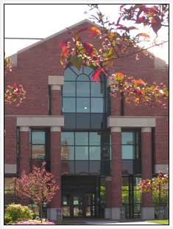
University of
Missouri – Columbia School of Law

Inclusion…

Dean R. Lawrence Dessem of the University of Missouri-Columbia School of Law (“MU Law”) met with MCBA President Pamela Meanes at a discussion the Dean held for Black alumni during the Missouri Bar Conference in September 2006. In a letter dated October 18, 2006, the Dean provided the MCBA with some insight on diversity initiatives currently taking place at the Law School. The Dean’s remarks are as follows:

Recruitment
- I am proud to report that we welcomed the most diverse entering class that we have ever had here at MU this fall. Thirty-three of our new 152 first-year students (22% of the class) are persons of color. Unfortunately, we still have challenges matriculating the numbers of African American students we would like to attract to the Law School. Seven of our first-year students are African Americans, which is one more than in last year’s first-year class, and we continue to look for ways in which we can attract more African American students. Prior-year statistics concerning the composition of the student bodies at all ABA-approved law schools are set forth in the ABA-LSAC Official Guide to ABA-Approved Law Schools, so I will not include these break-downs in this letter.

- Because of the very fine law schools in St. Louis and Kansas City, we sometimes have a challenge attracting individual students from those cities to Columbia (particularly if there is an employed spouse or partner in those cities). We therefore have worked with the undergraduate admissions officials here at MU in an effort to expand the numbers of persons of color in the MU undergraduate programs (from which about one-third of our entering law school class is drawn).

- We also have worked with Missouri law firms to create diversity scholarships at the Law School, scholarships that have helped us in both diversifying our student body and in training outstanding persons of color to enter the legal profession.

- Our outreach efforts have expanded and intensified since last January, when we added the new position of Director of Student Diversity Programs at the Law School. J. R. Swanegan is a recent graduate of the Law School, and he has expanded our outreach to persons of color not only within the admissions process.

- We include among the career and graduate fairs at which we recruit students trips to Historically Black Colleges and Universities—including such universities as Lincoln University here in Missouri and Florida A & M. Visits to LSAC fora in cities such as Atlanta, the District of Columbia, and Chicago also result in contacts with people of color with whom we talk about the Law School, and we have traveled to the CLEO program in Kansas City in an effort to interest students in MU.

- We regularly participate in the LSAC February programming to reach out to people of color before their last few years of college. In addition, we have hosted students participating in the MU Walton Leadership Conference and the Missouri Legislative Black Caucus Youth Leadership Conference, and J. R. Swanegan has spoken at the Youth Leadership Conference (and in other settings) about law school and the law school admissions process.

- We recently have filed an application to host one of the CLEO summer programs in 2007, several of which were held here at MU in the 1990s.

Retention/Preparation
- [O]ur own BLSA chapter funds a scholarship each year—in connection with our annual Lloyd Gaines celebration. Gaines received an honorary degree from the University of Missouri last spring (the University waiving the rule that such degrees can only be awarded to living persons), and Gaines’ nephew, George Gaines, has visited the Law School on several occasions within the last few years. In connection with this year’s event, not only George Gaines, but the NAACP Associate General Counsel, will be visiting the Law School and speaking with our students.

- [The Director of Student Diversity Programs] also works with our students on issues of academic success, student development, career development, and placement. J. R. has established a very successful mentoring program for our minority students, bringing back to the Law School many of our alumni of color to counsel and provide a resource for our minority students. He also has established a Student Diversity Advisory Board, which has provided helpful and candid suggestions to both J. R. and the Law School. J. R.’s “Lunch with a Lawyer” series also has been very successful, even resulting in externships for some of the students involved. My own “Dean’s Roundtable” program includes minority and African American students and attorneys each year as well. In addition to his work at the Law School, J. R. Swanegan has attended within the last year the NALP Diversity Summit in Chicago and the NCBE Conference on Improving Minority Bar Passage, as well as other such conferences.

- Along with other Missouri law schools, we participate in such programs as the St. Louis Minority Clerkship Program (established by the Mound City Bar Association and law schools including MU), the Heartland Diversity Job Fair (of which MU was a founding member), the Hispanic Diversity Career Fair in St. Louis, and the Cook County Bar Association Minority Job Fair.

- As do the other Missouri law schools, we appreciate the way in which a diverse faculty can help to attract a more diverse student body. We were pleased to welcome to our tenure-track faculty this year Professor David Mitchell, who is African American and came to us from a fellowship at the University of Colorado. A new adjunct professor teaching in our legal writing program each semester this year is another African-American attorney, Erika Fadel, and this year’s Altria Fellow (working with students in our Family Violence Clinic) is Cecilia Young, an African-American graduate of our Law School.

- I have used our major, endowed speaker series to bring several African-American lawyers to the Law School to spend a day interacting with our students. Three of our last four James D. Ellis Lawyers from Practice have been African American (including ABA President Robert Grey, Deputy Attorney General Larry Thompson, and Time magazine’s legal affairs correspondent Sonja Steptoe). In addition to giving an address to the entire law school community, sharing lunch with the faculty, and speaking in individual classes, these distinguished visitors also have a separate session with our BLSA students.

- Three years ago we partnered with the University of the Western Cape in Cape Town, South Africa to establish a Summer Program in Cape Town. In at least a few instances, this has helped to interest potential African-American students in MU, and African-American law students from across the country have joined our own students, and students from the University of the Western Cape, in these summer programs.

or Illusion?

In addition to the information above, gained from the MU Law dean, the Education Commission conducted its own research and interviewed current MU BLSA students and recent MU Law alumni. Those findings are below.

- Students and alumni expressed their belief that MU Law administrators are well-intentioned in their quest for diversity. However, they added that MU Law’s diversity initiatives could be more effective if someone who had studied diversity and learned to infuse it into every aspect of the law school experience was working on the diversity efforts.

- During the years of the study, less than five Black law students were members of any of the student law journals or moot court. In many instances, the number of Black law students participating in these important organizations was less than three.

- Although the law school states that it participates in the St. Louis Minority Clerkship Program, some students and alumni stated that the MU Law Career Services Office failed to inform them about the program.

- Students and alumni indicated that MU Law students seem to be at a disadvantage in the Kansas City and St. Louis legal job markets because the Missouri’s other three law schools are located in those cities. Students and alumni expressed frustration that it seems as if only the top 20% of each graduating class obtain private law firm jobs in these cities, especially with large law firms. Unfortunately, the majority of the Black students fall in the bottom 80% of their classes and are disproportionately affected by this issue.

- Students and alumni expressed that BLSA invited its own speakers and organized trips to the Cook County and Heartland Minority Job Fairs. They stated that BLSA often operated as the law school’s diversity director. They added that the new, official diversity director has taken on many of the tasks and events that BLSA usually executed.

- Some students and alumni stated their feeling that diversity at the law school is an agenda that students become lost in.

- Despite MU Law’s promotion of the Lloyd Gaines celebration, students and alumni indicated that no law school class, program, or event, studies the historic case of Missouri ex rel. Gaines v. Canada, 305 U.S. 337 (1938), a constitutional law case which laid the foundation for the NAACP’s success in Brown v. Board of Education.

- Students also noted that the law school offers a course on gender and the law, but not on race and the law. They stated that law school courses fail to adequately address race issues in the law on more than a surface basis.

- Students and recent alum stated that MU Law often gives the perception that the Lloyd Gaines Scholarship event is an MU Law-sponsored event. However, BLSA hosts and plans the event with a little less than 10% funding donations from the law school. For the 2007 scholarship event, BLSA students have invited George Gaines, the nephew of Lloyd Gaines, and the NAACP Associate General Counsel to the celebration.

- The University of Missouri-Columbia has funded the MU Law Director of Diversity position for two years. Currently, it is not a long-term position. However, the law school has stated that it is trying to secure funds to extend the position beyond two years and make it long term.

- Some BLSA officers expressed frustration to the MU Law administrators with the selection process for the newly-created Director of Diversity position.

- Students and alumni expressed that MU Law “uses BLSA as its diversity weapon.”

- Students and alumni expressed concern that the MU Law Career Services Office knowingly invites or allows law firms to participate in On Campus Interviewing that have negative histories in hiring African Americans.

- Students and alumni stated that they felt isolated in relationships with professors. They expressed frustration that MU Law too heavily relies on the University of Missouri-Columbia’s African-American Deputy Chancellor to recruit and support Black students. In addition to being an MU Law alumnus, the deputy chancellor is an alumnus of the University’s undergraduate program. In addition to the overall student body, undergraduate, graduate, and professional African-American students throughout the University look to the deputy chancellor for support. Consequently, MU Law students and alumni indicated that the deputy chancellor, despite his goodwill and readiness to help, cannot give, and should not be expected to give, the support and advice that Black law students need when they need it. Students and alumni expressed that the deputy chancellor cannot be all things to all people.

- Current students expressed concern that the current BLSA faculty sponsor, who has been a great help and resource for BLSA, will be retiring in 2007.

Source: NALP Directory of Law Schools

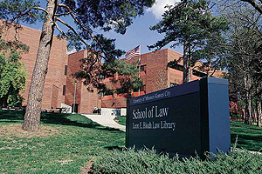
University of Missouri – Kansas City School of Law

Inclusion…

In a letter dated October 20, 2006, Dean Ellen Y. Suni provided the MCBA with some insight on diversity initiatives currently taking place at the Law School. The MCBA did not receive this letter until November 20, 2006; thus, it did not have an opportunity to analyze its contents as extensively as the other Missouri law schools. The Dean’s remarks are as follows:

Recruitment
- UMKC School of Law faces the same challenges as other law schools in recruiting students and faculty of color, and the fact that we are in an urban area presents both additional challenges and opportunities.

- With regard to students of color, our approach to admissions is of a holistic nature in that we use factors in addition to the LSAT and GPA that are consistent with the University’s values of diversity, inclusiveness and respect for racial, ethnic, cultural, gender, age or other forms of diversity. We also look for applicants who have triumphed over challenges and barriers based on societal discrimination or economic disadvantage. We understand that all decisions cannot be made based solely on the written application materials, and therefore we interview potential students as necessary. Over the last three years we have extended an annual average of 43 offers to minority students and have averaged 16 matriculations. Our philosophy is that we will only admit those students who are likely to be successful at UMKC irrespective of race. Although we continue to be disappointed at the number of minorities in our School, we are very pleased with our low attrition and high bar passage rates for minority students and graduates over the past several years, which confirm that we are indeed admitting students who will be successful.
- Our admissions process is overseen by our Assistant Dean for Admissions and Multicultural Affairs, who is an African American female graduate of this law school. Last year we added a part-time recruiter/admissions assistant to help with recruitment efforts, including a particular focus on recruiting students of color. This position is filled by Sherrie Nash, a Hispanic graduate of UMKC School of Law. Together with our admissions coordinator, also an African American female, they handle the admissions effort. All are committed to increasing the diversity of the School.

- Our recruitment efforts are extensive and include visits to HBCU’s, placement of advertisements in HBCU and other minority mediums as well as pipeline initiatives such as co-sponsoring a local spelling bee and providing scholarships for all bee participants.

- We also host the Kansas City Youth Court (they have offices and hold court in our courtroom complex, and their staff is largely students and faculty at the School), a diversion program in which central city middle and high school students are trained to serve as attorneys and judges in cases diverted from Family Court. We work closely with those students to encourage them to seek law as a career.

- We annually hire a SLIP student to work at the Law School and sponsor all the participants in the SLIP program for a luncheon at the Law School.

- We are actively working to develop additional pipeline initiatives focused on K-12 schools and community colleges and are in the process of hiring a graduate assistant to coordinate these efforts.

- At the later stages of the pipeline, we work very closely with CLEO. In fact, we hosted one of the two 2005 Summer Law Institutes. UMKC law school faculty and staff have participated in the CLEO Attitude Is Essential program over the last several years and in the inaugural Achieving Success in the Application Process seminars this past summer in Atlanta and Los Angeles.

- We host two annual diversity day events co-sponsored by LSAC in which churches and schools are sent invitations to have their students and community members participate.

- In addition, as we are part of a larger university, we work very closely with other academic units and the admissions office to attract and retain students.

- We have a number of full and partial scholarships for students of color. Our Chancellor’s scholarships, jointly funded by the University and our Law Foundation provide full tuition and a small stipend for books, and our Wal-Mart Scholarship for Minority Students covers tuition, fees and one study abroad opportunity as well as the bar exam preparation course. In addition, diversity merit scholarships provide partial tuition assistance. We are actively involved in fund-raising and working with local firms to increase the availability of scholarships for students of color.

Retention/Preparation
- Once students are here, we work to provide the environment and support necessary to facilitate success. We have a Student Services Manager (who is Asian-American) who provides counseling and non-academic assistance to students. We also have a Director of Academic Support as well as an Associate Director of Academic Support and Bar Services (who is an African-American male) to help ensure the success of all law students as well as two mentoring programs – the Inns of UMKC, which is open to all students, and a program coordinated with the minority specialty bar associations.
- In addition, students and members of the legal community are invited to an annual minority welcome reception sponsored by our Minority Affairs Advisory Committee, supported by a local law firm and held at the home of one of our minority graduates.
- UMKC is fortunate to have the support of the grater Kansas City area legal community in its efforts to attract, recruit and retain students of color. We believe these efforts have contributed to the success of our students of color in completing law school and passing the bar.
- Many of our minority students are active in the law school community. We have had, and continue to have, students of color represented as editors of our journals, as leaders of our national appellate and trial advocacy programs, serving as research and teaching assistants and emissaries as well as participating in student organizations including BLSA, HLSA and AAPI and non-minority student groups. In addition, the minority student organizations work with and support each others’ efforts. Many of our minority graduates are very successful lawyers, and many serve as judges and leaders of the bar.
- While still have a way to go in increasing diversity on our faculty, we have made progress in the past two years. Because of university budget constraints, we have not had significant hiring opportunities over the past several years, but for Fall 2005, we were able to hire three new faculty. We made offers to three faculty of color and were able to secure two of them (the third declined only because of family constraints), a Hispanic female and an African-American female. In addition, as noted, we recently hired an African-American male to serve as Associate Director of Academic Support and Bar Services and teach in our legal writing program.
- In addition to attempting to diversify our faculty, we have encouraged existing faculty to become more aware of diversity issues and to actively include diverse perspectives in their classes. Our Inclusion and Empowerment Committee has put on programming to educate members of the law school community about issues of race and ethnicity, and several of our faculty have participated in the University’s diversity infusion program and are revising their curricula to incorporate these perspectives.
- The Law School’s diversity efforts are part of a larger local effort to diversify the Kansas City bar. We co-sponsor activities with specialty bars, the Johnson County NAACP, and the Hispanic Chamber of Commerce. In addition, the KCMBA, member firms and the law school signed a historic commitment to diversity and we work on events with them (e.g., Heartland Diversity Fair) as well as serve on the Diversity Committee.
or Illusion?

As noted above, the Commission did not have an opportunity to analyze the trends noted in the Dean’s letter included in the Appendix. Accordingly, the results from NALP are provided for review.

Source: NALP Directory of Law Schools

National Trends

Contextually, it is important to evaluate whether the Missouri law schools are affected by trends unique to this area. An analysis of the Commission’s focus area suggests that certain issues are not particular to Missouri.

Recruitment
- Students of color generally lag behind national averages in application, admission, and graduation rates. In fall 2005, African American students accounted for 10.4% of all applications submitted to ABA-accredited law schools.
- Since 1996, law school enrollment for students of color has been stagnant at 19-21% of all applicants.
- During the same period, African American enrollment fell 6.7%.
- African American students generally score lower on the LSAT and therefore have a lower chance of getting accepted into law school.

Retention
- Black law students have a higher attrition rate than White law students.

Preparation
- Nationally, 88% of all Bar exam takers pass on their first attempt and 95% pass eventually. On average, only 61% of Blacks first-time takers pass the Bar and only 78% pass eventually.
- Law students of color in the class of 2004 obtained only 19.7% of the 30,035 legal jobs available across the nation.

RECOMMENDATIONS

At the heart of any successful conflict resolution is a willingness on the part of the participants to seek a solution. The diversity positions articulated through letters and on the websites of the Missouri law schools clearly indicate a desire to move forward towards a more diverse legal academy. However, active involvement from the private bar and Black law students is equally essential if the goals of this Study are to have any meaning. To that end, below are our recommendations geared toward actively affecting change. In addition, we are adopting certain recommendations proposed by the American Bar Association and the National Bar Association for immediate implementation in the state of Missouri.

I. Recommendations for the Mound City Bar Association

In response to the above findings, the Education Commission recommends that the Mound City Bar Association commit itself to (1) maintain a strong relationship with the law students at the area law schools, (2) assist law students with the transition to the legal profession, (3) financially support law students, (4) promote the practice of law to minority students of all ages, (5) encourage alumni involvement in pursuing change at Missouri law schools, (6) interview alumni in an effort to better understand the issues, and (7) sponsor a symposium in 2007 with the goal of strategizing, empowering, and implementing certain recommendations contained in this Report. These recommendations are detailed below.
(1) Maintain Strong Relationship Between Law Students and the Bar Association
The Mound City Bar Association (“MCBA”) should be a guiding light and resource to the Black men and women who aspire to enter the legal profession. As a bar association, MCBA must invest in the legal talent that will lead the organization during the next generation. When the law students individually or as a group need advice or assistance, MCBA should be prepared to assist them or direct them to the appropriate resources. The law schools may be unable or unwilling to focus any efforts directly for Black students, but MCBA can do it. A strong relationship is built on trust and commitment. Therefore, to maintain a strong relationship between the area law students and the Mound City Bar Association, the Education Commission recommends that the Mound City Bar Association:
(a) Appoint a Mound City Bar Association member to serve as a law school liaison for area law schools.
This person would serve as the contact person between the law students at Washington University in St. Louis, Saint Louis University, and the University of Missouri-Columbia, and MCBA. This liaison will stay informed about the events at the area law schools including recruiting dates, academic schedules, and events planned by the Black Law Students Associations at each school. This person will coordinate joint activities between the law students and MCBA. This person will coordinate the professional development and academic programs hosted by the Mound City Bar Association for these law students.
(b) Send representatives from the Membership and Young Lawyers Committees to the Black Law Students Association meetings at Washington University and St. Louis University at the beginning of the fall semester.
The representatives will introduce the students to MCBA and sign them up for their free membership.
(c) Sponsor a reception for the law students in the area during the summer hosted by the Young Lawyers Committee.
The reception will provide an opportunity for the students to attend a MCBA meeting and meet area lawyers active in the association.
(d) Sponsor a spring social activity with the law students and MCBA members.
The activity would be a casual activity that would allow the law students and MCBA members to have a good time. These activities could include golf, bowling, or any group activity.
(e) Purchase a table at the Mound City Bar Foundation’s Scholarship Dinner for students who want to attend.
This will ensure that the students who may have financial difficulties can attend the Scholarship Dinner. The students can celebrate with the scholarship recipients and meet hundreds of attorneys in our area.
(f) Purchase tickets and/or attend the premier events sponsored by the Black Law Students Associations.
These events include Washington University’s Dr. Martin Luther King. Jr. Dinner, the University of Missouri-Columbia’s Lloyd Gaines Scholarship Dinner, and Saint Louis University’s Judicial Reception.
(2) Assist Law Students with Transition to the Legal Profession
As many MCBA members know, it is difficult to enter the legal profession, especially for those of us who were first generation college students and the first professionals in our families. The MCBA is in a unique position to guide and advise the law students about the challenges and rewards of a legal career, therefore, MCBA should provide the following seminar opportunities to the area law students in preparation for all aspects of their law school and legal careers. The MCBA Law School Liaison will be integral to the coordination of these seminars with the law students at the appropriate times.
(a) Professional Excellence Seminar-The Professional Development Committee should host seminars on interviewing, professional appearance, resume and cover letter preparation, general business etiquette, and networking. These seminars should take place once each semester at each school (unless the students desire to have a joint session) before On-Campus Interviews, or first-year interviews, begin in the spring.
(b) Academic Excellence Seminar- The Young Lawyers Committee should sponsor a seminar on academics including preparation for exams, consultations with professors, the proper use of study aids, and time management.
(c) Publications Seminar- The Professional Development Committee should gather a group of MCBA members who have published law review articles or served on a law journal for advice regarding preparation for the law review competition, the benefits and challenges of being a law review member, and how to get an article published if not selected for law review. These seminars should take place before the law review competitions begin at each school.
(d) Legal Writing Seminar- The Professional Development Committee should organize a seminar on legal writing consisting of judges, law firm partners, and law clerks to introduce students to the differences between law school writing and professional legal writing. This seminar will take place after final examinations and before the summer clerkships begin.
(e) Networking and Leadership Seminar- The Membership Committee should host a seminar led by former law school campus leaders on the importance of connections with faculty and classmates, joining and leading majority on campus, and political or community activities.
(f) Legal Careers Panel- The Professional Development Committee will host a seminar on the wide variety of legal careers of the MCBA membership. This Legal Careers Panel will consist of a fair where the students (in high school, college, and law school) can receive information about different practice areas and a panel discussion where attorneys from lesser known practice areas talk about their entry into that area of law and provide insight in response to students’ questions.
(g) Examination of the Bar Exam- The Membership Committee and the Young Lawyers Committee should host a reception for newly graduated law students after graduation and before preparation for the bar exam begins. The reception can be a picnic or barbeque, which would immediately follow a presentation on how to prepare mentally and substantively for the bar exam.
(3) Support Students Financially with Legal Education or Experience
In the past, the MCBA financially assisted law students with the Scovel Richardson Scholarship. The Mound City Bar Foundation has continued this endeavor. Therefore, MCBA should do the following to continue its commitment of providing financial assistance to area law students:
(a) Accomplishment- MCBA should recommend to the Foundation that it highlight the successes of past recipients and show how the scholarship money was very useful to the recipients. It should be prestigious for students to receive this award.
(b) Advertising- Recommend that the Foundation advertises the scholarship at the area law schools before Spring Break, to avoid the conflict with final exam preparation.
(c) Notification- Recommend that the Foundation personally mail applications to all Black Law Students Association members at each area law school.
(d) Support- Donate money to the Mound City Bar Foundation each year for the Scovel Richardson Scholarships. Additionally, the MCBA should encourage its members, especially past scholarship recipients, to make donations to the scholarship funds.
(4) Promote the Practice of Law to Minority Students of all Ages
The MCBA should actively promote the practice of law to minority students of all ages. As African-Americans, we are painfully aware of the uses and misuses of our country’s legal operations. MCBA desires to provide positive role models and experiences of legal institutions to our community. Therefore, the MCBA should promote positive images of the law and the importance of civil rights and liberties to young people by doing the following:
(a) Experience- Recommend that the Mound City Bar Foundation sponsor a student in the St. Louis Intern Program. If the funds of the Mound City Bar Association permit, the Association should sponsor a student in the St. Louis Intern Program.
(b) Development- Encourage MCBA members with trial experience volunteer to coach a high school mock trial team in the annual mock trial competition held by the Bar Association of Metropolitan St. Louis.
(c) Knowledge- The Community Affairs Committee should hold monthly one hour meetings on the legal system in St. Louis area public schools or at local community youth organizations.
(5) Encourage Alumni Action Directed Towards Missouri Law Schools
As alumni of the Missouri law schools, MCBA members have a vested interest in ensuring that the values of our law degrees improve over time. Beyond that, as recipients of benefits conferred in part because of an appreciation for diversity, it is incumbent on alumni to inform the current administrations of any concerns that exist. To that end, on an individual or collective basis, MCBA members should direct correspondence to the Deans of their respective alma maters requesting re-instatement of abandoned diversity initiatives and/or offering assistance for current endeavors.
(6) Interview Former Students From 2002 – 2005
With few exceptions, the numbers gathered from NALP for the period of our study were left to speak for themselves. If former Black law students are available to speak to the conditions existing at the Missouri law schools from 2002-2005, then a more complete portrait of the numbers is possible. Once complete, the interviews can serve as a center-piece to any addendums to this report.
(7) MCBA Sponsorship of a Strategic Planning Session in 2007
Planning and partnership is key to the realization of benefits made available by a more diverse student body. Appropriately, this responsibility does not belong to any one group interested in seeing Black law students succeed. Rather, enthusiastic participation from the private Bar, law schools, law firms, and law students is necessary to actively identify and address the issues. The Survey was the first attempt to identify the issues. The Law Students’ Panel was the second. Going forward, a strategic planning conference is suggested whereby the parties above can assign action items geared towards implementing recommendations that are feasible to the particular realities experienced by the Missouri law schools.
II. Recommendations for Missouri Law Schools

A. MCBA’S Recommendations

MCBA makes the following recommendations to the four Missouri law schools based on this Report’s findings. Recommendations for a specific school will be addressed as such.

(1) Law school administrators and professors should work to form an alliance with BLSA as an organization and with its students individually. This will help to alleviate student and alumni perceptions that the law schools use BLSA only to recruit African-American students.
(2) Form alliances with the MCBA, Jackson County Bar Association, National Bar Associations, and other specialty bar associations purposed to support the Black community.
(3) Implement a plan to successfully recruit and retain Black law students as members of Law Review, specialty journals, and moot court.
(4) Implement a plan to place more Black law students in research assistant positions with professors.
(5) The law schools should take an active role in planning diversity programs for the entire student bodies that are separate and distinct from BLSA programs and events.
(6) Annually survey students and alumni, especially African-Americans, to gage the effectiveness of implemented diversity initiatives.
(7) Invite African-American students to take a part in implementing diversity initiatives in a variety of aspects. Do not limit their participation to calling newly-admitted perspective Black students.
(8) Emphasize to African-American students the importance of participating in On Campus Interviewing as well as in minority job fairs, especially in their first year of law school. Implement a system or program to ensure that all students, African-American students particularly, are well-informed about OCI and job fairs and the relevant dates.
(9) MCBA recommends that SLU Law re-visit the original purpose and goals of its Summer Institute program. Evaluate the program’s mission statement; or, develop a mission statement if none exists. Additionally, the law school should examine the necessity of the current program as structured. Moreover, SLU should examine whether the SI is, in actuality, a program to help prepare participants for, and predict their success in, law school, or whether the SI has, in effect, become a program to test a disproportionate number of minority students’ competencies for law school. MCBA further recommends that SLU Law examine the effects of the SI program on the overall well-being of its minority students, specifically African Americans.
(10) MCBA further recommends that SLU Law examine ways to provide scholarships, grants and funding to successful SI participants who are admitted to the law school at summer’s end after most financial aid has been awarded.
B. Recommendations for Law Schools (from the ABA Conference “Embracing the Opportunities for Increasing Diversity into the Legal Profession: Collaborating to Expand the Pipeline”)

In addition to the above recommendation, MCBA adopts the following recommendations verbatim from the ABA:
(1) Educat[e] students about the rigors and requirements of the admissions process.
(2) Encourag[e] and support[] adherence to the LSAC Cautionary Policies on the use of LSAT scores, particularly with regard to the relative unimportance of small score differences and the inappropriateness of using cut-off scores. LSAC Cautionary Policies can be found at www.LSACnet.org in the “Publications” section.
(3) Address[] other stumbling blocks that surface after students successfully navigate the admissions proves, includ[ing] the inability (or unwillingness) of some law schools to create and foster an inclusive and welcoming environment for racially and ethnically diverse students, and poor academic students of color in the first year. The lack of a nurturing and accepting campus environment often leads to feelings of isolation among students of color, which can have a direct impact on attrition rates.
(4) Identify existing programs that help law school students succeed academically, and work toward:
(a) Increasing minority student participation in these existing “general population” pipeline programs
(b) Developing comparable programs, when needed, that are specifically adapted to attract minority participants
(5) Encourage all law schools to evaluate their need for diversity pipeline programming and to develop pipeline initiatives based on those evaluations.
(6) Increase the number of minority law professors by:
(a) Encouraging practicing lawyers of color to become law professors
(b) Encouraging law schools to recruit, hire, and retain more minority law professors
(7) Encourage law schools to devote resources for the academic support of minority students, including:
(a) Assessing the effectiveness of existing academic support programs
(b) Developing effective academic support and summer enrichment programs in all law schools that need them
(c) Providing skill development, career awareness, and educational pathway programming
(8) Encourage law schools to engage in effective diversity outreach that extends deeper into the pipeline by:
(a) Developing a tool kit for law students to mentor K-12 students
(b) Supporting the establishment of summer enrichment programs targeted to minority K-12 and college students
(c) Developing collaborations with existing community college programs that provide opportunities for promoting legal careers
C. Recommendations for Law Schools (from the National Bar Association’s President’s Report on Law School Diversity).
The MCBA adopts the following recommendations verbatim from the National Bar Association:
(1) Requir[e] that admissions and accreditation practices that have a disparate impact on enrollment of students of color be valid, reliable, and supported by published studies correlating those practices with increased professional competence; and
(2) Increas[e] the transparency of law school admissions and accreditation practices that have a disparate impact on enrollment of students of color by making the basis for those practices public and providing public access to the data and studies supporting those practices.
CONCLUSION
The AALS describes the challenge as developing “an educational community--and ultimately an America--where all of us can work together and learn from each other in a climate of mutual trust. Hard times bring out fears, but they can also call forth from persons of goodwill the best qualities that lie within them.” Recognizing that illusions are sometimes the consequence of good intentions gone bad, we encourage readers to resist the temptation to reach a conclusion without first considering the many dynamics at work. Some of the findings were indeed a cause for alarm. Others were hopeful. Still others led to yet further unanswered questions. What is clear is that the conversation must continue, followed by action items and tools of accountability to ensure that everyone is involved in building a better legal reality. Society demands as much; and if legal profession fails to take the lead in providing a remedy, the profession will be held accountable by the communities we serve.

APPENDIX

Mound City Bar Association
2006 Education Commission Survey
Examining law school dynamics from Fall 2002 – Spring 2005*

*- except where indicated
Definitions & Instructions
As used in this survey, the terms “you,” “your,” and “Law School” refer to the Law School administration, faculty, staff, and any other entity or individual reasonably expected to act on the Law School’s behalf.
Unless stated otherwise, “Black” or “African American” refers to a person having origins in any of the Black racial groups of Africa, South America, or the Caribbean. Where “African” is used to refer to a nationality, it includes individuals of the Black racial groups born in Africa.
Unless stated otherwise, all questions refer to the academic years 2002 - 2005.
Completed surveys should be returned via the enclosed envelope to Mound City Bar Association, c/o Education Commission, P.O. Box 1543, St. Louis, MO 63188.
Please direct inquiries to Keisha Patrick at kipatrick@hotmail.com or 314-482-4441.
Questions

1. In what ways has the U.S. Supreme Court decision in Grutter v. Bollinger, 539 U.S. 306 (2003) impacted or altered your admissions/recruitment efforts? Explain.
2. Do you distinguish recruiting efforts geared towards Africans or other international students of color from recruiting tools geared towards African Americans? Why or why not.
3. (a) From which undergraduate institutions do you recruit Black applicants? (b) On which schools do you conduct on-campus visits? (c) Is there an admissions preference for certain feeder schools or geographic region?
4. (a) Is there racial diversity in the Admissions Office? (b) Is there a person in the Admissions Office focused exclusively on diversity recruitment? (c) If not, does the Law School have any plans of creating such a position? (d) If so, for how long has this position existed? (e) What is the recruitment/admissions mandate of that person?
Tables
5. Are admission decisions made by a Committee? If so, please indicate the make-up of the committee during the 2002 – 2005 academic years.
Law School Admissions Committee Composition
 | 2002-2003 | 2003-2004 | 2004-2005 | TOTAL
Number of administrators
Number of Black administrators
Number of tenured Professors
Number of non-tenured professors
Number of Black tenured professors
Number of Black non-tenured professors
Number of alumni
Number of Black alumni
Number of law students
Number of Black law students
Other
TOTAL

6. Please fill in the following table with the appropriate information re law student academic performance.
2002-2003
Academic Percentiles | Number of Black Students |  | TOTAL
Academic Percentiles | Men | Women | TOTAL
Top 5%
Top 10%
Top 25%
Top 33.3%
Top 50%
Top 80%
Less than 80%

2003-2004
Academic Percentiles | Number of Black Students |  | TOTAL
Academic Percentiles | Men | Women | TOTAL
Top 5%
Top 10%
Top 25%
Top 33.3%
Top 50%
Top 80%
Less than 80%

2004-2005
Academic Percentiles | Number of Black Students |  | TOTAL
Academic Percentiles | Men | Women | TOTAL
Top 5%
Top 10%
Top 25%
Top 33.3%
Top 50%
Top 80%
Less than 80%
7. Please fill in the following table with the appropriate information re the number and dollar value of scholarships you awarded to law students. Please use actual numbers and dollar values instead of percentages; e.g. “10 students received a total of $100,000 in scholarship aid” is right, whereas “10% of our students received financial assistance for 80% of their law school costs” is wrong.
 | Black Students |  | All Students
 | Number of Students with Scholarships | Dollar Value of Scholarships | Number of Students with Scholarships | Dollar Value of Scholarships
2002-2003
2003-2004
2004-2005
TOTAL

8. Please fill in the following table with the appropriate information re the composition of the Law School faculty.
 | 2002-2003 | 2003-2004 | 2004-2005 | TOTAL
Number of full-time professors
Number of tenured full-time professors
Number of Black full-time professors
Number of tenured Black full-time professors
TOTAL

9. Please fill out the table with the appropriate information re law student retention.
2002-2003
Students Dismissed/  Transferred |  | Students Re-Admitted (from prior dismissal) |  | Black Students Dismissed/  Transferred |  | Black Students that Re-Applied |  | Black Students Re-Admitted (from prior dismissal)
Men | Women | Men | Women | Men | Women | Men | Women | Men | Women

2003-2004
Students  Dismissed/  Transferred |  | Students Re-Admitted (from prior dismissal) |  | Black Students Dismissed/  Transferred |  | Black Students that Re-Applied |  | Black Students Re-Admitted (from prior dismissal)
Men | Women | Men | Women | Men | Women | Men | Women | Men | Women

2004-2005
Students  Dismissed/  Transferred |  | Students Re-Admitted (from prior dismissal) |  | Black Students Dismissed/  Transferred |  | Black Students that Re-Applied (within 1 year) |  | Black Students Re-Admitted (from prior dismissal)
Men | Women | Men | Women | Men | Women | Men | Women | Men | Women

10. How many Black students were on law review, law journal, or specialty journals from 2002 - 2005? How many Black students have works published from 2002 - 2005?

 | All Students |  |  |  | Black Students
 | Law Review | Teaching Assistant | Research Assistant | Moot Court | Law Review | Teaching Assistant | Research Assistant | Moot Court
2002-2003
2003-2004
2004-2005
TOTAL
11. Please fill out the table with the appropriate information re career services and employment opportunities for law students.

 | Number of submissions for on-campus interview | Number of on-campus interviews | Number of summer clerkships from OCI | Number of participants in Minority Clerkship Program | Number of permanent offers from MCP
2002-2003
2003-2004
2004-2005

12. (a) Please fill out the table with the appropriate information re average LSAT scores for admitted students.

Average LSAT scores for admitted students | All Students |  |  | Black Students
Average LSAT scores for admitted students | Men | Women | TOTAL | Men | Women | TOTAL
2002-2003
2003-2004
2004-2005

(b) If scores for Blacks trail the overall average, what academic support does the Law School offer to admitted Black students with lower LSAT scores?
13. Please fill out the table with the appropriate information re Bar passage rates.

Missouri Bar Exam
 | Number of JD graduates  (Spring) | Number of Black JD graduates  (Spring) | Number of students sitting for July Bar Exam | Number of Black students sitting for July Bar Exam | Number of students who passed July Bar Exam | Number of Black students who passed July Bar Exam
2003
2004
2005

Illinois Bar Exam
 | Number of JD graduates  (Spring) | Number of Black JD graduates  (Spring) | Number of students sitting for February Bar Exam | Number of Black students sitting for February Bar Exam | Number of students who passed February Bar Exam | Number of Black students who passed February Bar Exam
2003
2004
2005
2006

14. Please provide a statement describing your diversity initiatives or any other information you feel will assist in understanding the Law School’s efforts to create a diverse student body.

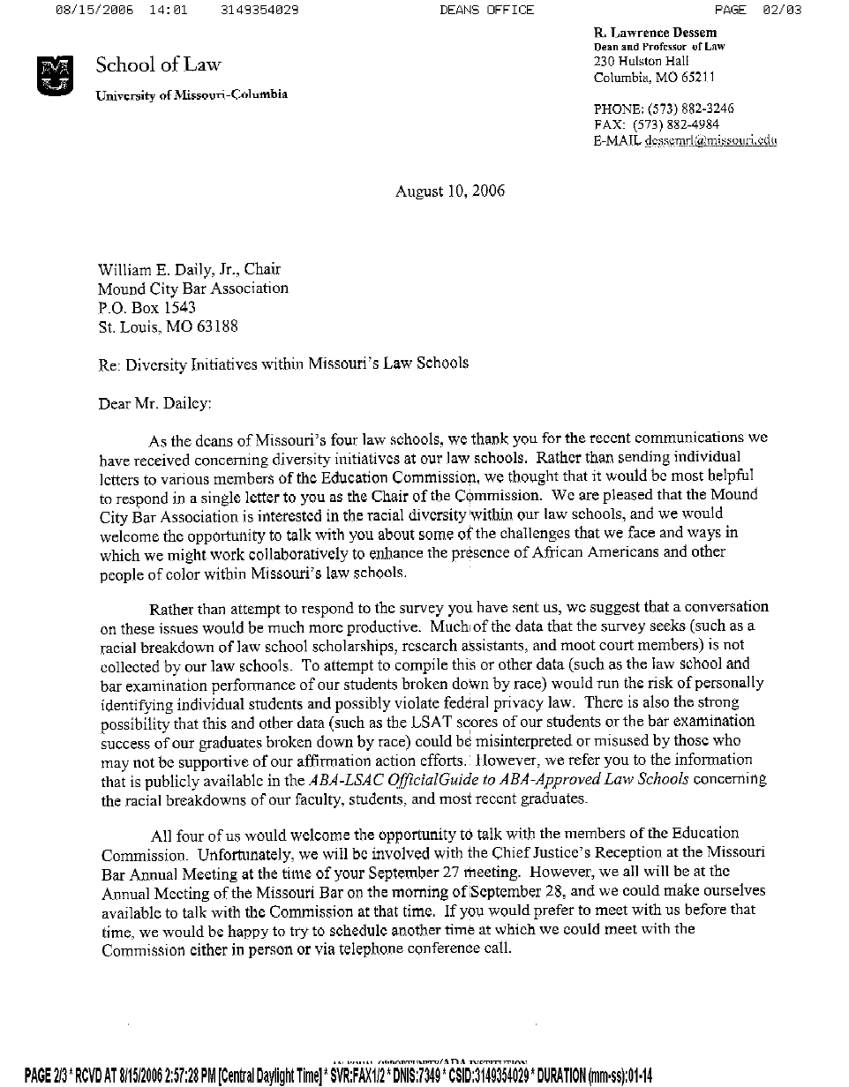
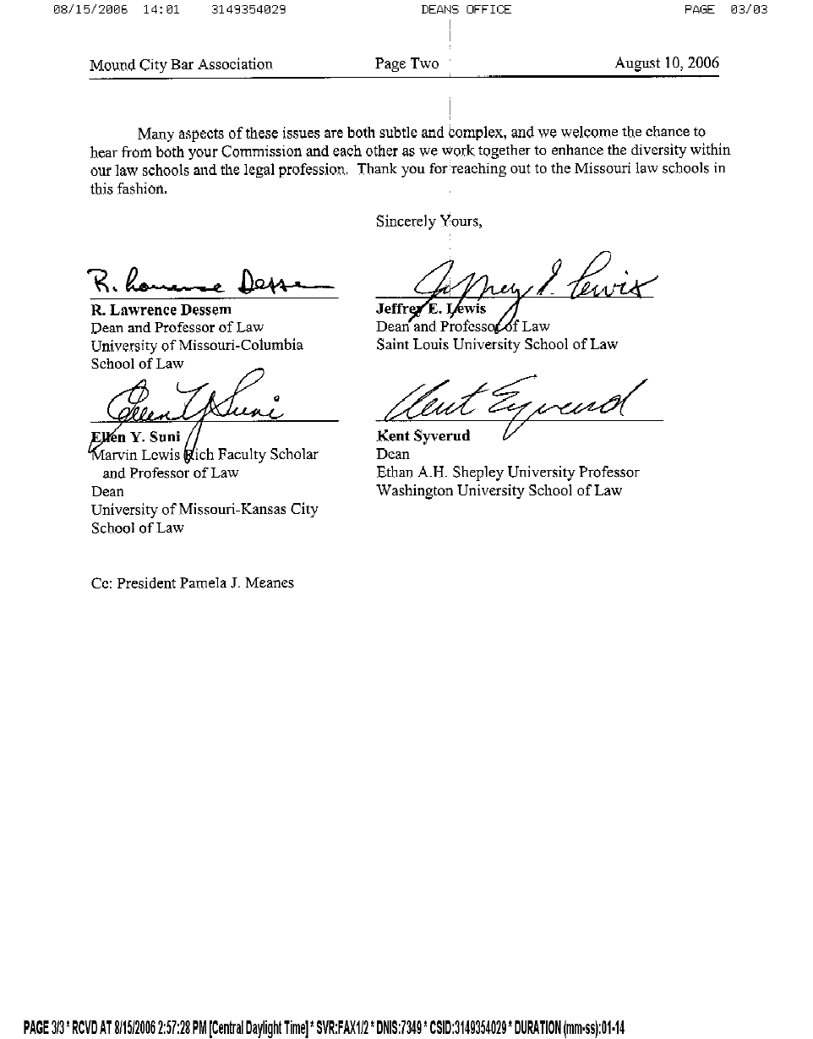
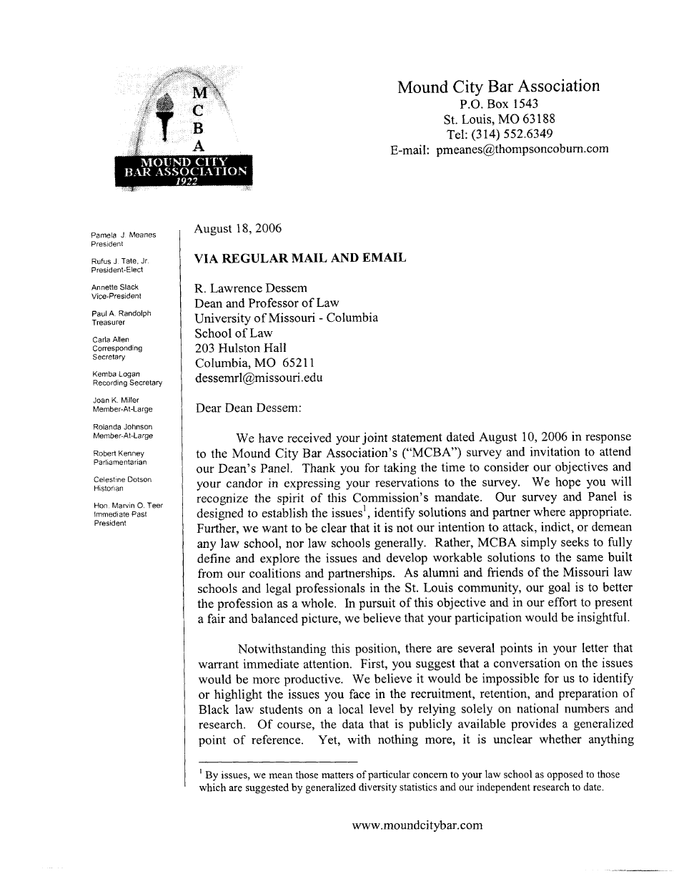
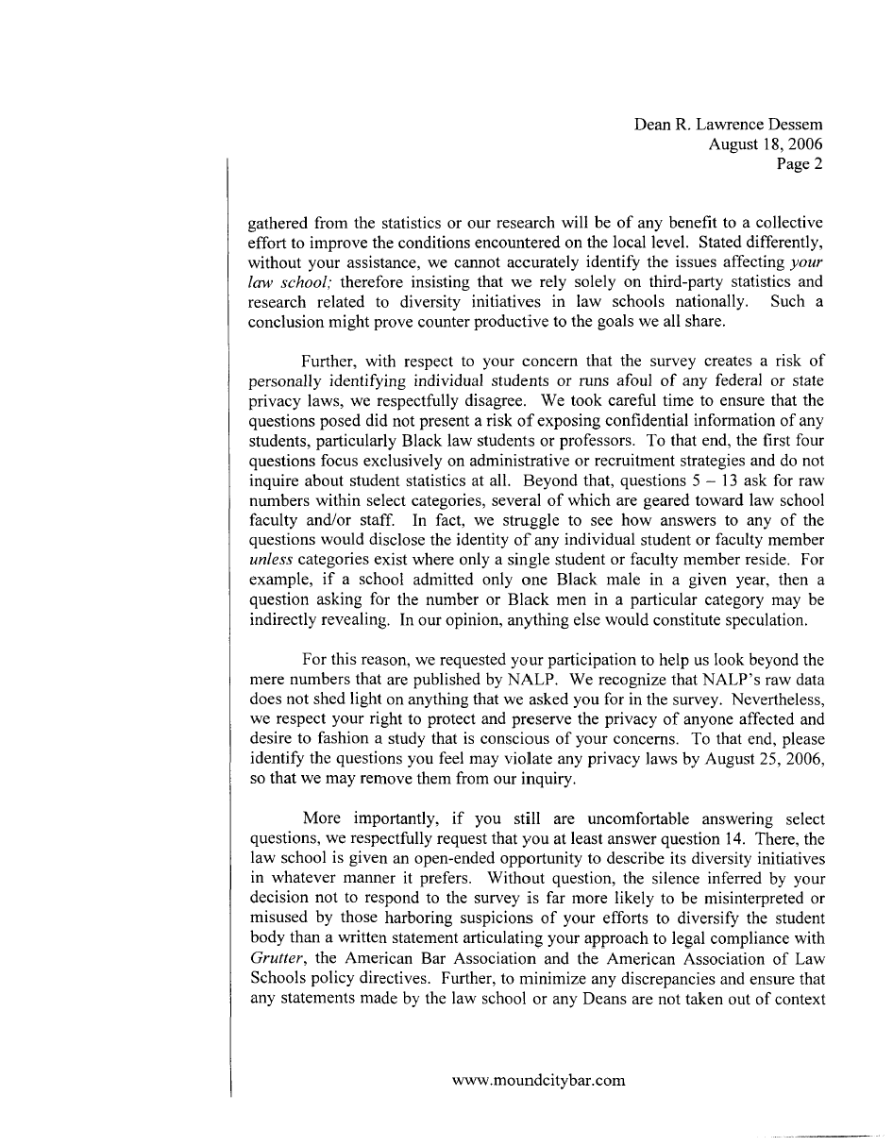
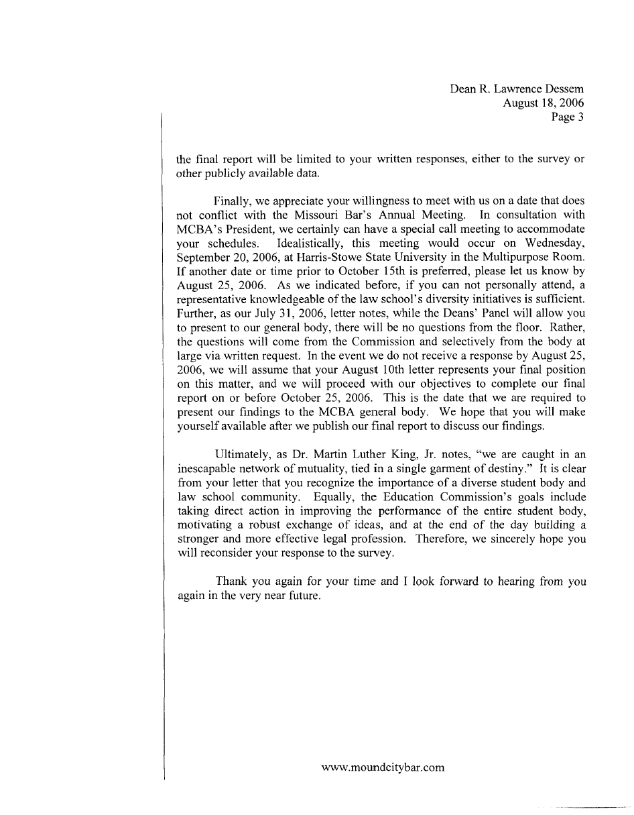
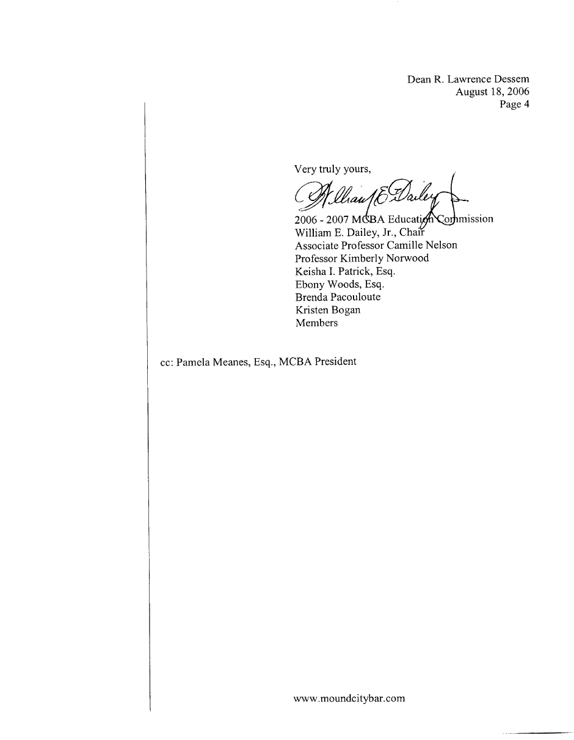
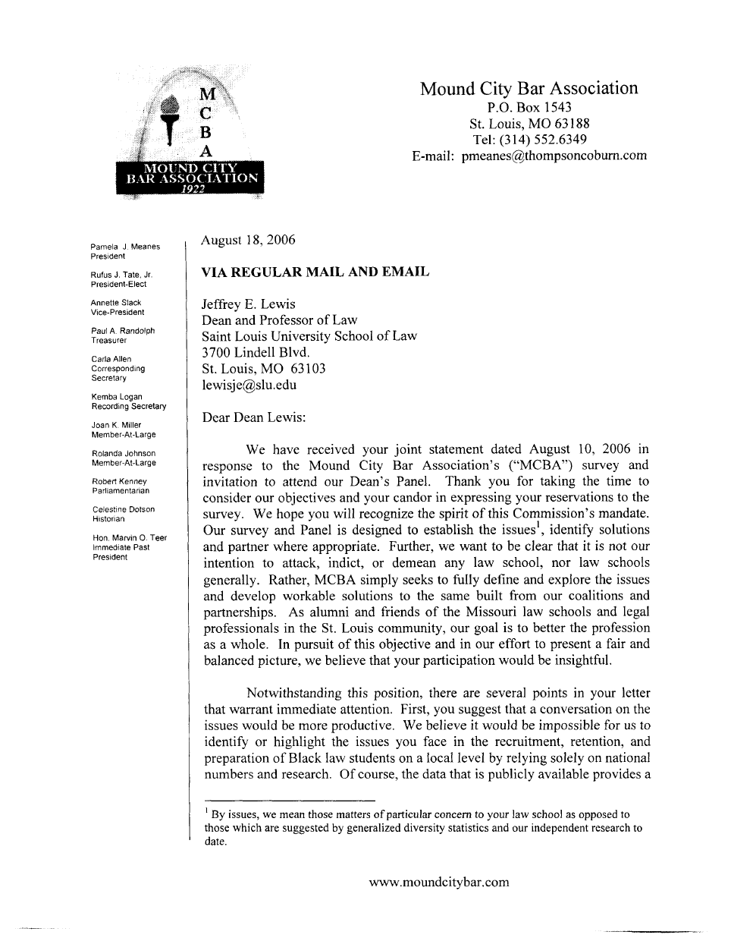
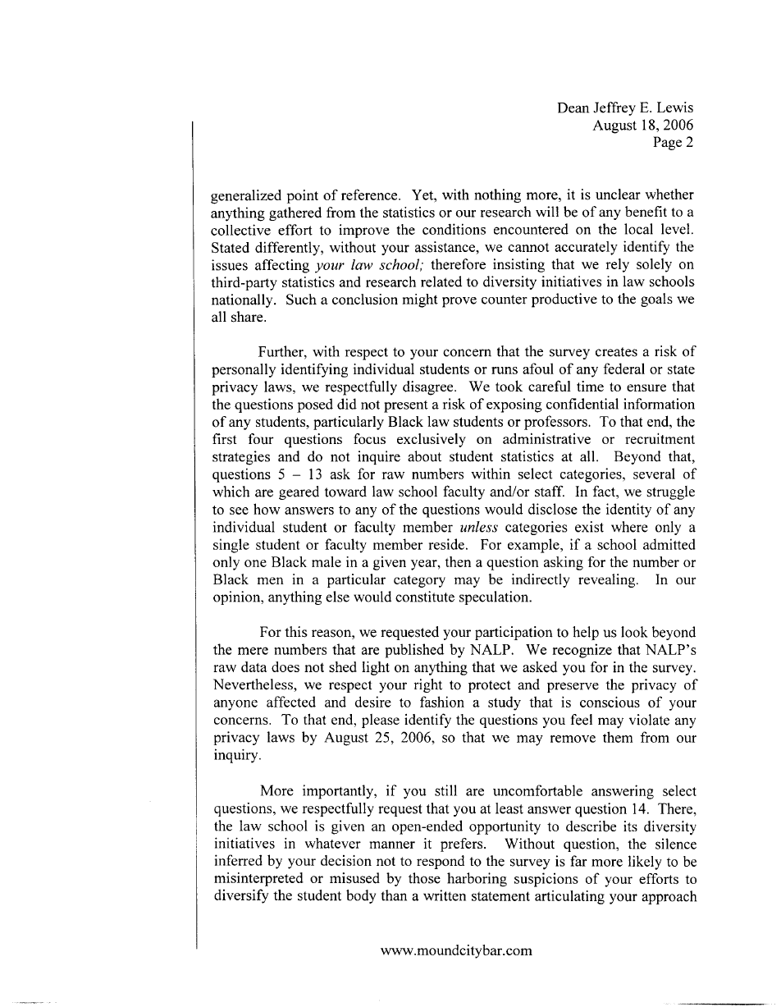
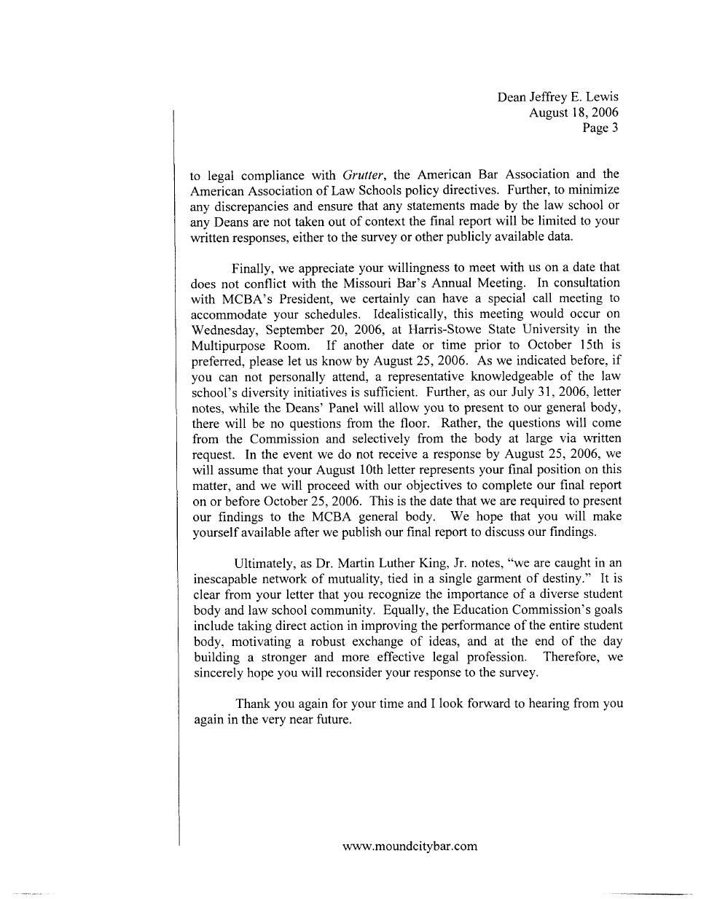
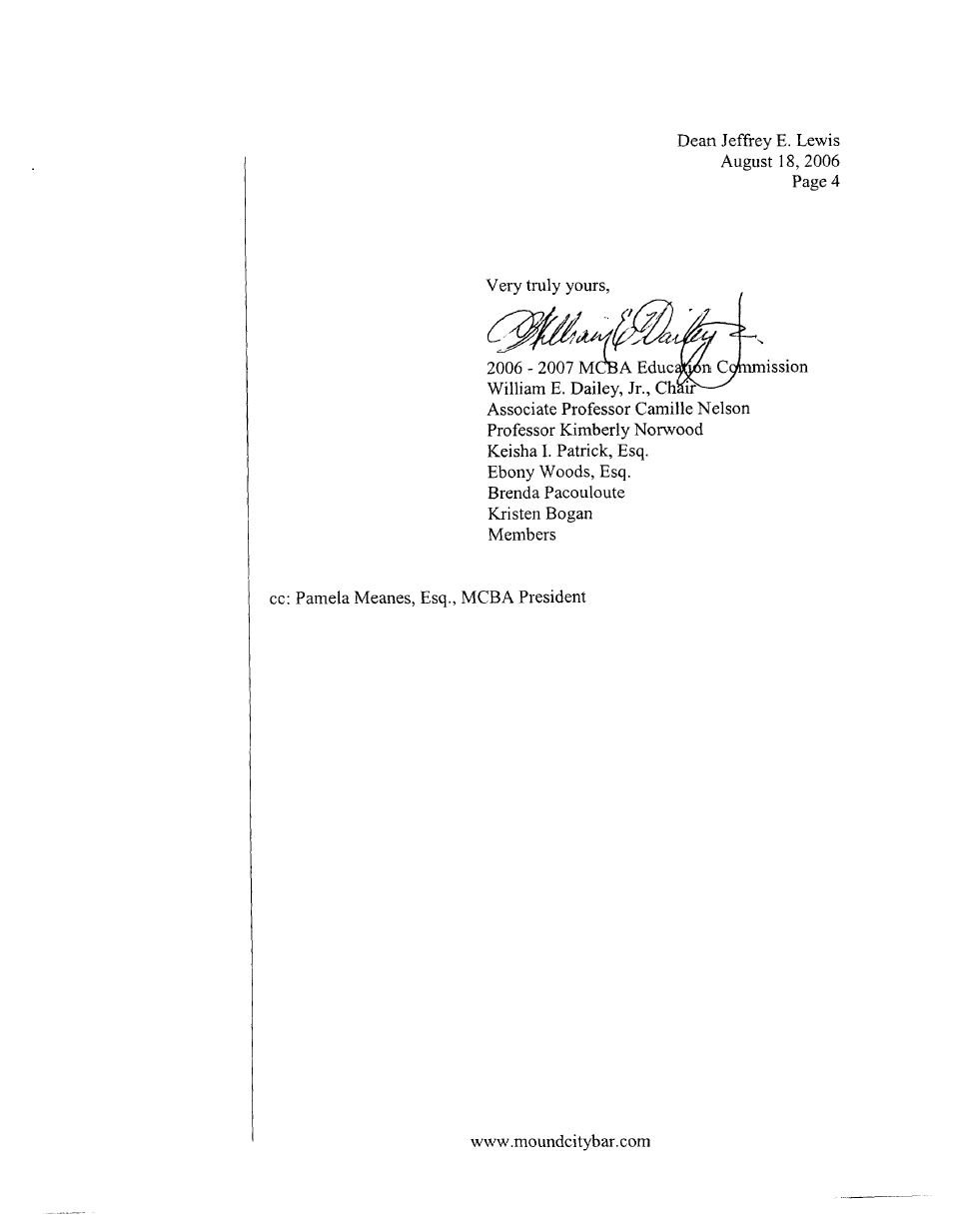
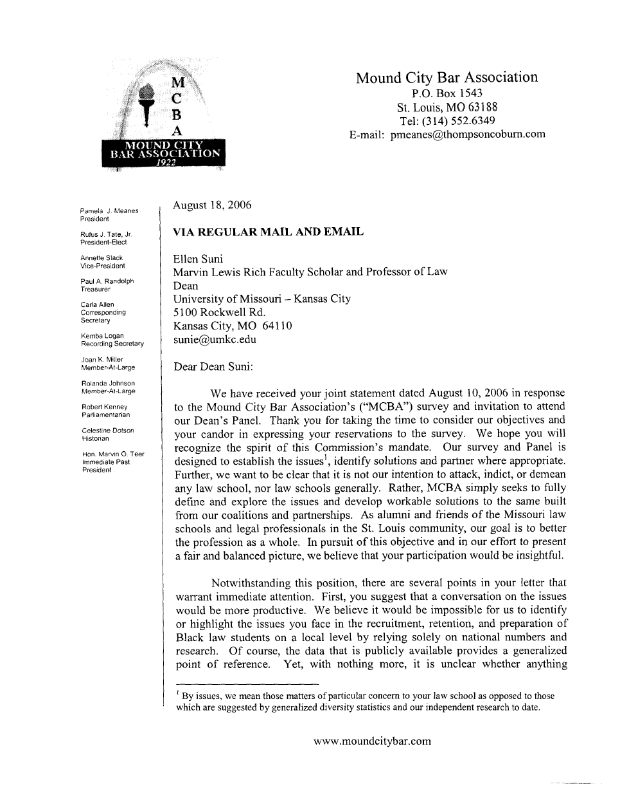
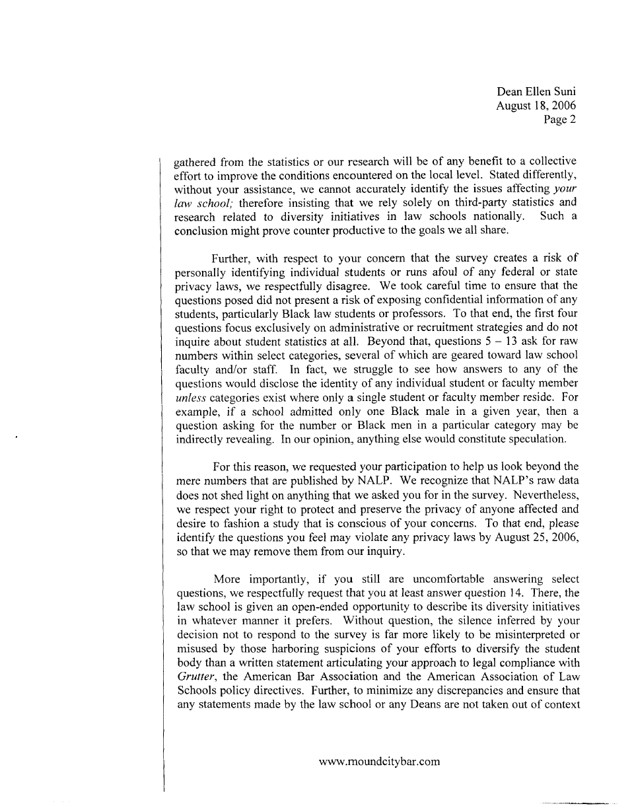
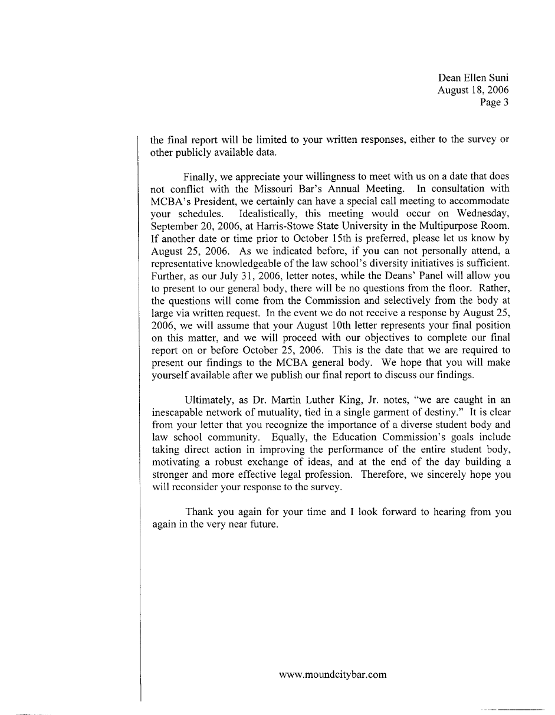
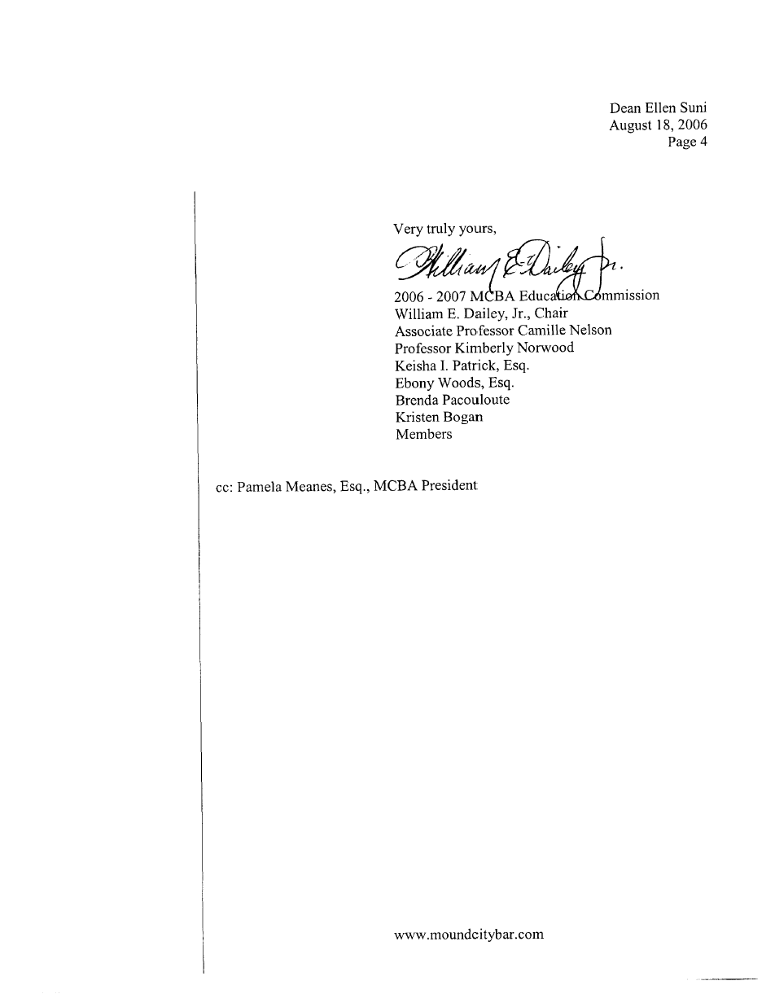
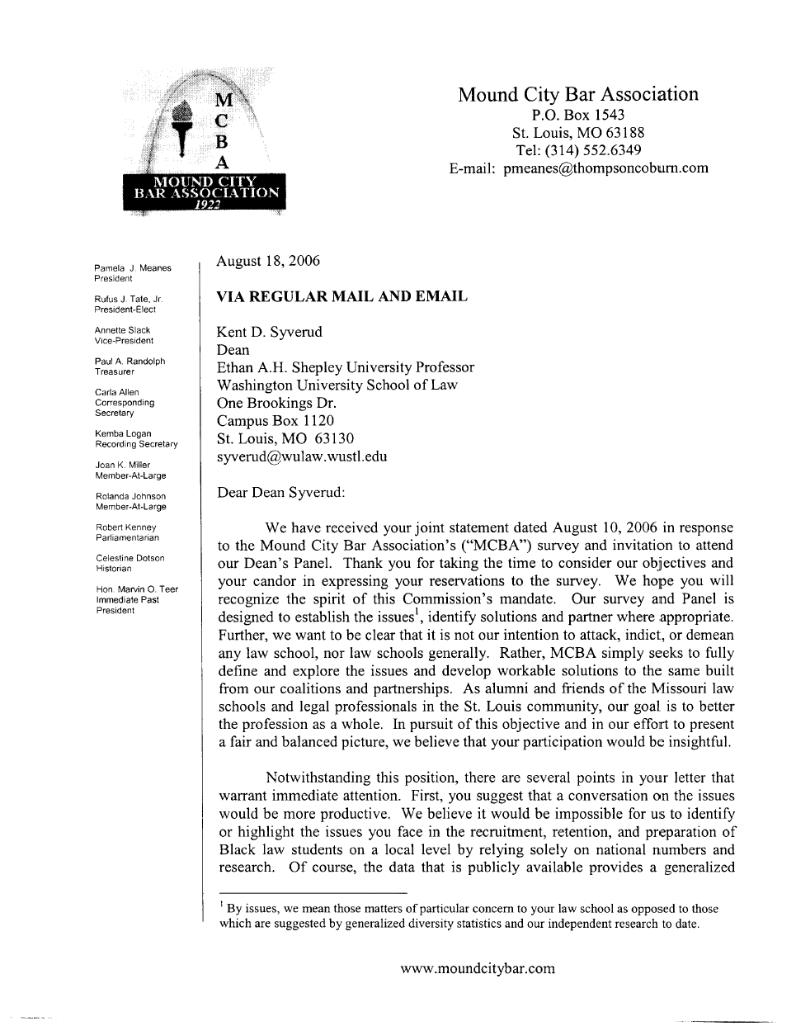
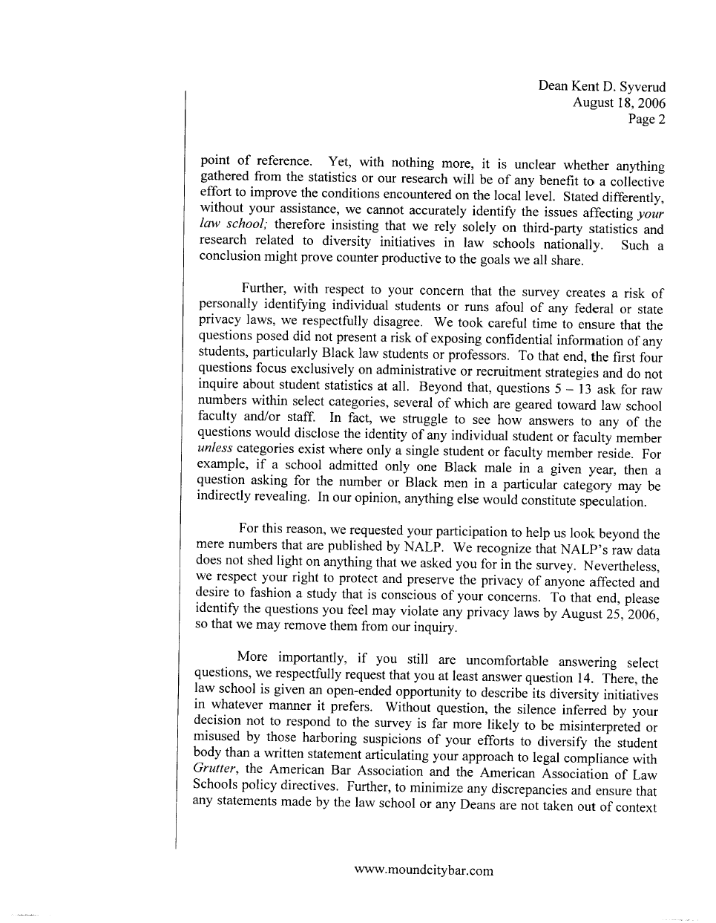
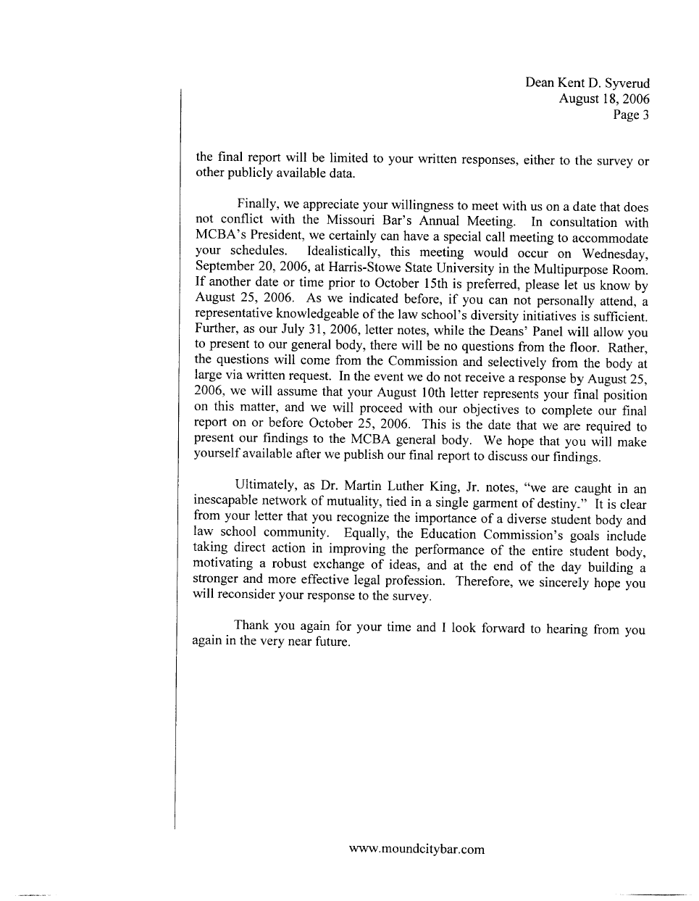
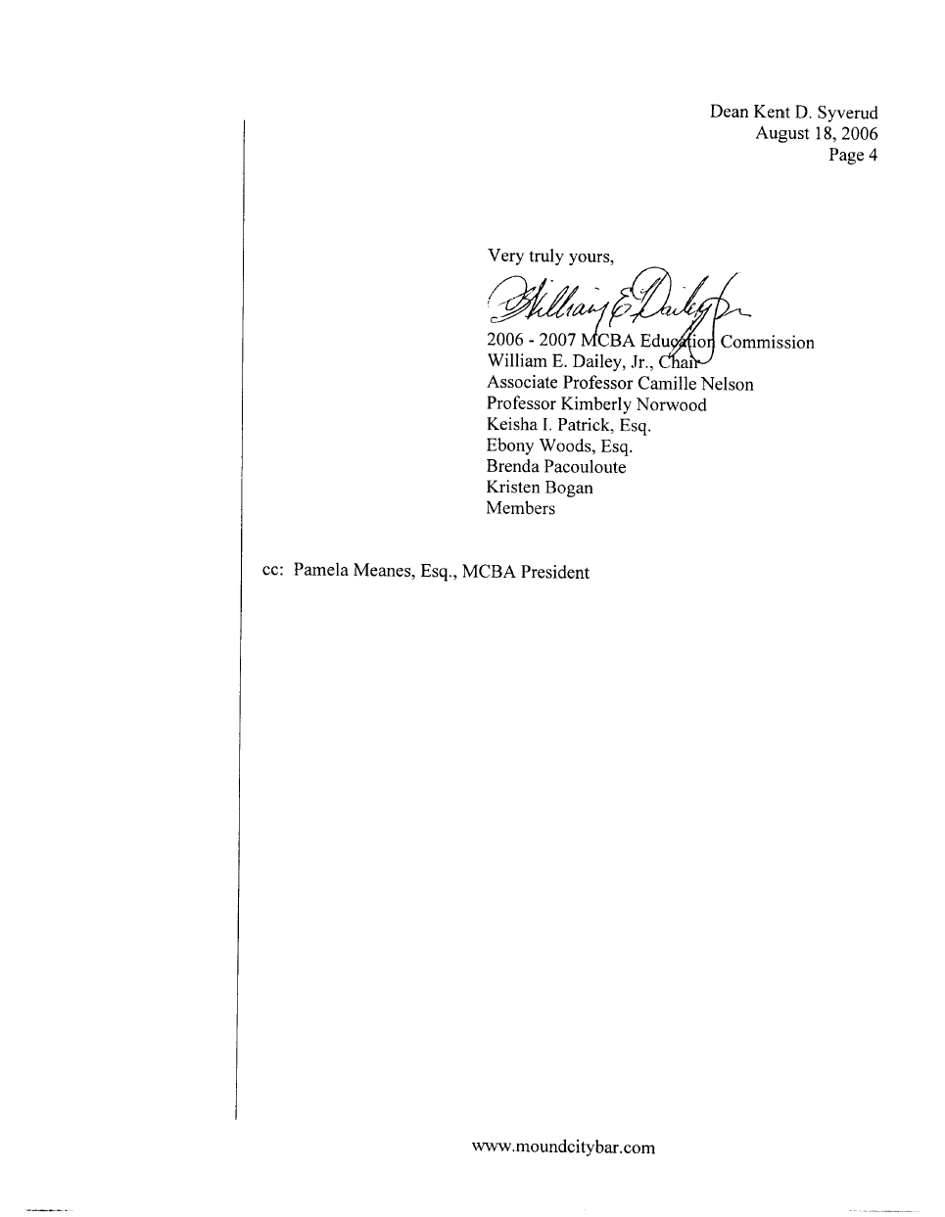
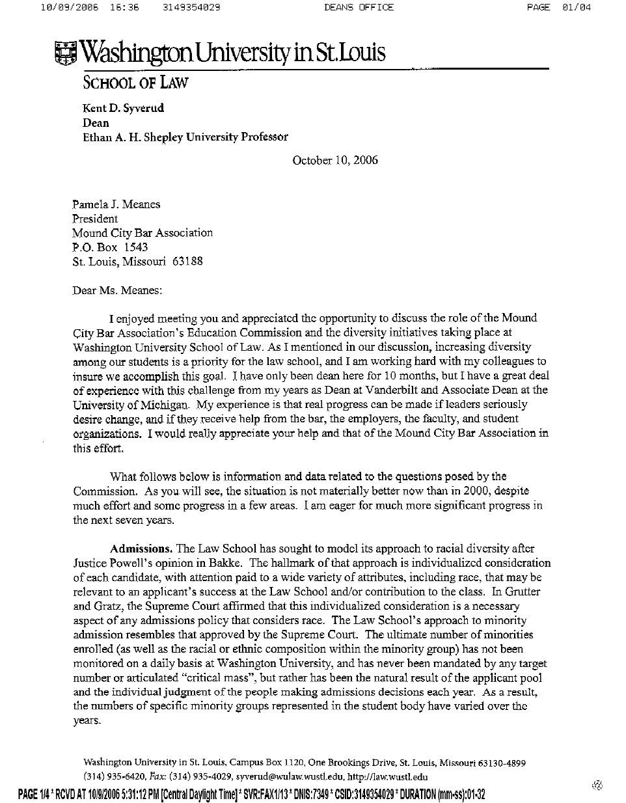
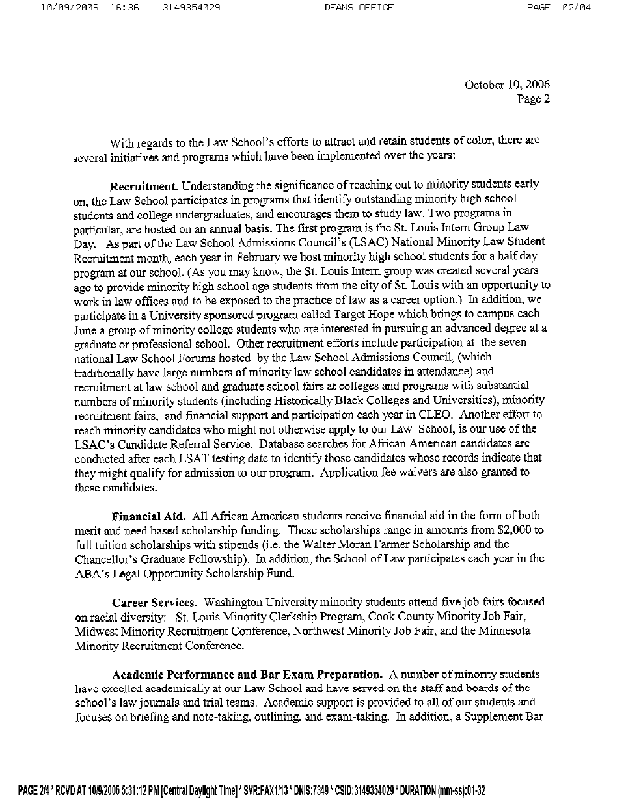
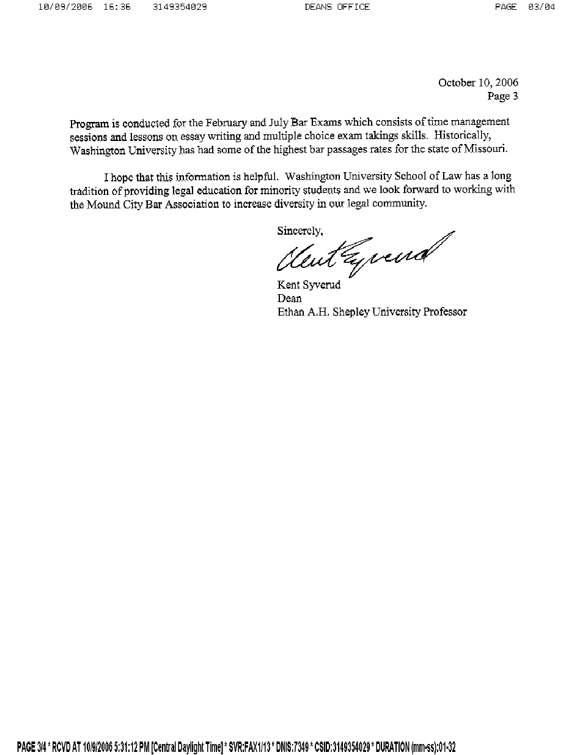
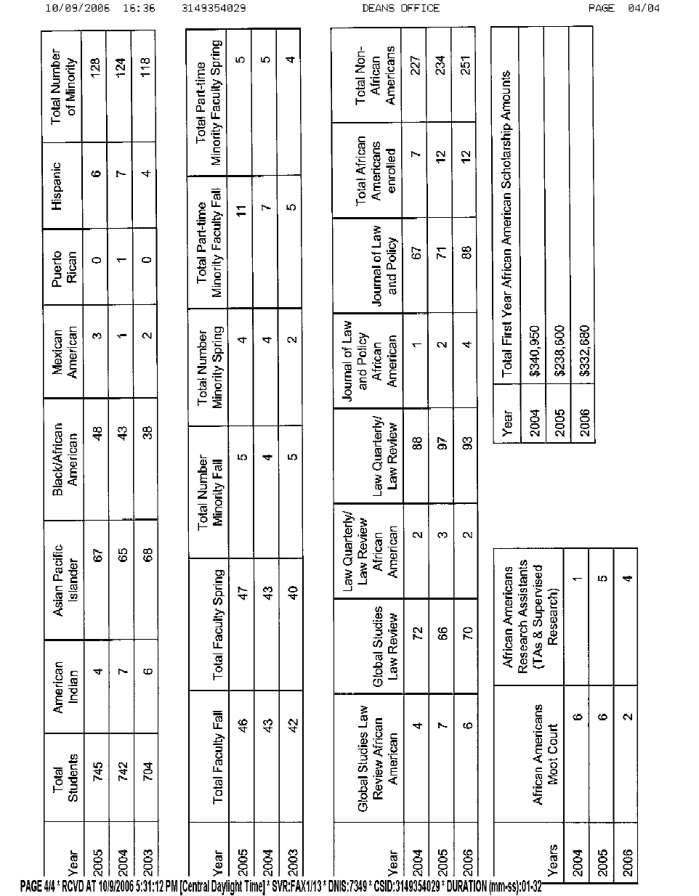
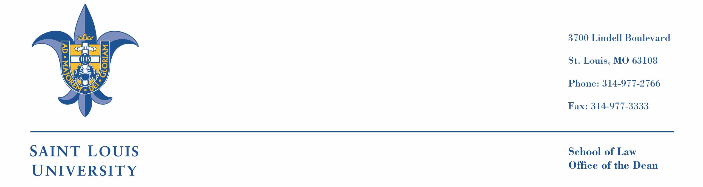

October 11, 2006

Pamela J. Meanes, Esq.
President, Mound City Bar Association
P.O. Box 1543
St. Louis, Missouri 63188

Dear Pam,

I write as a follow up to our conversation over lunch last month. I appreciated very much the opportunity to visit with you. I will be grateful for your help and that of your colleagues at the Mound City Bar Association. In particular, I hope and trust that we will have an opportunity for further discussion concerning participation in our efforts to attract, educate and place outstanding minority students.

Saint Louis University School of Law is committed to having a highly qualified and diverse student body. Our initiatives and goals are guided by the teachings of the Supreme Court of the United States. We have no quotas. We look at each individual file of an applicant with a view to the overall contributions which that applicant may make to our law school and to the legal profession.

Minority student enrollment at Saint Louis University School of Law has averaged 92 students over the last five years, though the numbers vary from year to year as the Admissions Committee makes careful and individuated decisions in review of several thousand files. This academic year we have 99 minority students enrolled in the School of Law. The Fall 2006 entering class was composed of 39 minority students who constitute 11.4% of the entering class. They are the most academically talented class of minority students ever to matriculate at the Law School, with a median LSAT score of 154 and a mean UGPA of 3.25. The composition of the class includes 1 American Indian, 12 Asian Americans, 18 African Americans, 1 Mexican American, 6 Hispanics, and 1 Pacific Islander. This composition, again, varies from year to year.

Our recruiting efforts are extensive and similar to those of law schools in general. Those efforts include every medium and technique, including visiting campuses of our traditional feeder schools and a number of historically black colleges. The many services of the Law School Admissions Council are especially helpful and fully utilized as part of our admissions program. Competition for qualified minority students is especially intense. We are, of course, subject to national trends. It was reported in the July 2006 Newsletter of the Law School Admissions Council that “African American applicants to law schools in 2005 declined by 668, or 6.3%, from Fall 2004, and the number of matriculants declined by 126, or 4.1%, between 2004 and 2005.” Our minority enrollment has remained fairly stable despite the national trends.

The Saint Louis faculty is more diverse than ever before. The full time faculty of 51 this academic year includes 29 males and 22 females and 6 faculty members of color. We believe there is an important synergy between our success in achieving a more diverse faculty and our efforts to recruit a more diverse student body. Overall, the more diverse our community, the more enriched is our academic environment.

One important aspect of our effort to reach out to disadvantaged students and others who have historically not been well represented in law schools is our Summer Institute. For many years the Admissions Committee has selected several dozen applicants whose academic credentials are marginal, but whose file suggests promise and whose presence in the student body would produce greater diversity. Those applicants are invited to attend the Summer Institute, free of any charge, for a seven week program of instruction taught by two members of the faculty. The program includes a research and writing course and a substantive law course, both of which conclude with examinations. This Fall eleven Summer Institute students are enrolled in the first year class.

In addition, we have instituted two outreach efforts with a long term view of increasing the local pool of qualified minority candidates with an interest in obtaining a legal education. Both efforts involve the St. Louis City schools.

Over the years we have taken steps to provide academic assistance to any members of the student body who are at academic risk. We have a full-time Director of Academic Advising, a half-time Writing Specialist, and a Legal Methods course in which second semester students whose first semester performance was sub par must enroll. While these resources/programs are available to the entire student body, they have been especially useful in providing support for our minority students.

We have also recently taken significant steps to enhance our efforts to increase the diversity of our student body and to achieve an enhanced nurturing and encouraging environment. The position of Director of Multi-Cultural Affairs was created last year and is currently held by a 1994 graduate of the University of Chicago Law School. We have a new Assistant Director of Admissions who is also especially focused on the recruitment of minority students. Finally, this Fall we have implemented the “Saturday School Program”; it is based on the successful Harvard Law School program of the same name and consists of three components: Speakers Series; Study Series; and Career Series. It is targeted especially for our minority students.

Let me say again that we will be grateful to the membership of the Mound City Bar Association for participation in and support of our various efforts to attract and nurture a diverse and successful student body at Saint Louis University School of Law.

With kindest personal regards, I am

Sincerely yours,


Jeffrey E. Lewis
Dean and Professor of Law

October 18, 2006

Ms. Pamela J. Meanes
President
Mound City Bar Association
P.O. Box 1543
St. Louis, MO 63188

Dear Pam,

It was good to meet you in St. Louis at the end of September, and I enjoyed talking with you at that time about the diversity issues that confront our law schools, the legal profession, and society more generally. I send this letter to provide you and other members of the Mound City Bar Association with more information concerning our diversity efforts here at the University of Missouri-Columbia School of Law. As I hope you and the other members of the Association appreciate, diversity is not only something that we value highly here in Columbia, but that the other three Missouri law schools and their deans also value and work to enhance both at our own law schools and within legal education and the profession.

Initially, I am proud to report that we welcomed the most diverse entering class that we have ever had here at MU this fall. Thirty-three of our new 152 first-year students (22% of the class) are persons of color. Unfortunately, we still have challenges matriculating the numbers of African American students we would like to attract to the Law School. Seven of our first-year students are African Americans, which is one more than in last year’s first-year class, and we continue to look for ways in which we can attract more African American students. Prior-year statistics concerning the composition of the student bodies at all ABA-approved law schools are set forth in the ABA-LSAC Official Guide to ABA-Approved Law Schools, so I will not include these break-downs in this letter.

Because of the very fine law schools in St. Louis and Kansas City, we sometimes have a challenge attracting individual students from those cities to Columbia (particularly if there is an employed spouse or partner in those cities). We therefore have worked with the undergraduate admissions officials here at MU in an effort to expand the numbers of persons of color in the MU undergraduate programs (from which about one-third of our entering law school class is drawn).

We also have worked with Missouri law firms to create diversity scholarships at the Law School, scholarships that have helped us in both diversifying our student body and in training outstanding persons of color to enter the legal profession. In addition, our own BLSA chapter funds a scholarship each year—in connection with our annual Lloyd Gaines celebration. Gaines received an honorary degree from the University of Missouri last spring (the University waiving the rule that such degrees can only be awarded to living persons), and Gaines’ nephew, George Gaines, has visited the Law School on several occasions within the last few years. In connection with this year’s event, not only George Gaines, but the NAACP Associate General Counsel, will be visiting the Law School and speaking with our students.

Our outreach efforts have expanded and intensified since last January, when we added the new position of Director of Student Diversity Programs at the Law School. J. R. Swanegan is a recent graduate of the Law School, and he has expanded our outreach to persons of color not only within the admissions process, but he also works with our students on issues of academic success, student development, career development, and placement. J. R. has established a very successful mentoring program for our minority students, bringing back to the Law School many of our alumni of color to counsel and provide a resource for our minority students. He also has established a Student Diversity Advisory Board, which has provided helpful and candid suggestions to both J. R. and the Law School. J. R.‘s “Lunch with a Lawyer” series also has been very successful, even resulting in externships for some of the students involved. My own “Dean’s Roundtable” program includes minority and African American students and attorneys each year as well. In addition to his work at the Law School, J. R. Swanegan has attended within the last year the NALP Diversity Summit in Chicago and the NCBE Conference on Improving Minority Bar Passage, as well as other such conferences.

Along with other Missouri law schools, we participate in such programs as the St. Louis Minority Clerkship Program (established by the Mound City Bar Association and law schools including MU), the Heartland Diversity Job Fair (of which MU was a founding member), the Hispanic Diversity Career Fair in St. Louis, and the Cook County Bar Association Minority Job Fair. We include among the career and graduate fairs at which we recruit students trips to Historically Black Colleges and Universities—including such universities as Lincoln University here in Missouri and Florida A & M. Visits to LSAC fora in cities such as Atlanta, the District of Columbia, and Chicago also result in contacts with people of color with whom we talk about the Law School, and we have traveled to the CLEO program in Kansas City in an effort to interest students in MU.

We regularly participate in the LSAC February programming to reach out to people of color before their last few years of college. In addition, we have hosted students participating in the MU Walton Leadership Conference and the Missouri Legislative Black Caucus Youth Leadership Conference, and J. R. Swanegan has spoken at the Youth Leadership Conference (and in other settings) about law school and the law school admissions process.

As do the other Missouri law schools, we appreciate the way in which a diverse faculty can help to attract a more diverse student body. We were pleased to welcome to our tenure-track faculty this year Professor David Mitchell, who is African American and came to us from a fellowship at the University of Colorado. A new adjunct professor teaching in our legal writing program each semester this year is another African-American attorney, Erika Fadel, and this year’s Altria Fellow (working with students in our Family Violence Clinic) is Cecilia Young, an African-American graduate of our Law School.

I have used our major, endowed speaker series to bring several African-American lawyers to the Law School to spend a day interacting with our students. Three of our last four James D. Ellis Lawyers from Practice have been African American (including ABA President Robert Grey, Deputy Attorney General Larry Thompson, and Time magazine’s legal affairs correspondent Sonja Steptoe). In addition to giving an address to the entire law school community, sharing lunch with the faculty, and speaking in individual classes, these distinguished visitors also have a separate session with our BLSA students.

Three years ago we partnered with the University of the Western Cape in Cape Town, South Africa to establish a Summer Program in Cape Town. In at least a few instances, this has helped to interest potential African-American students in MU, and African-American law students from across the country have joined our own students, and students from the University of the Western Cape, in these summer programs. We recently have filed an application to host one of the CLEO summer programs in 2007, several of which were held here at MU in the 1990s.

As you can see from the above, we continue to look for creative ways in which to enhance the diversity of our student body and our Law School. The thoughts and suggestions of you and your colleagues within the Mound City Bar Association would be welcome as we work on these issues of common concern.

Very truly yours,

R. Lawrence Dessem
Dean and Professor of Law

RLD/jt

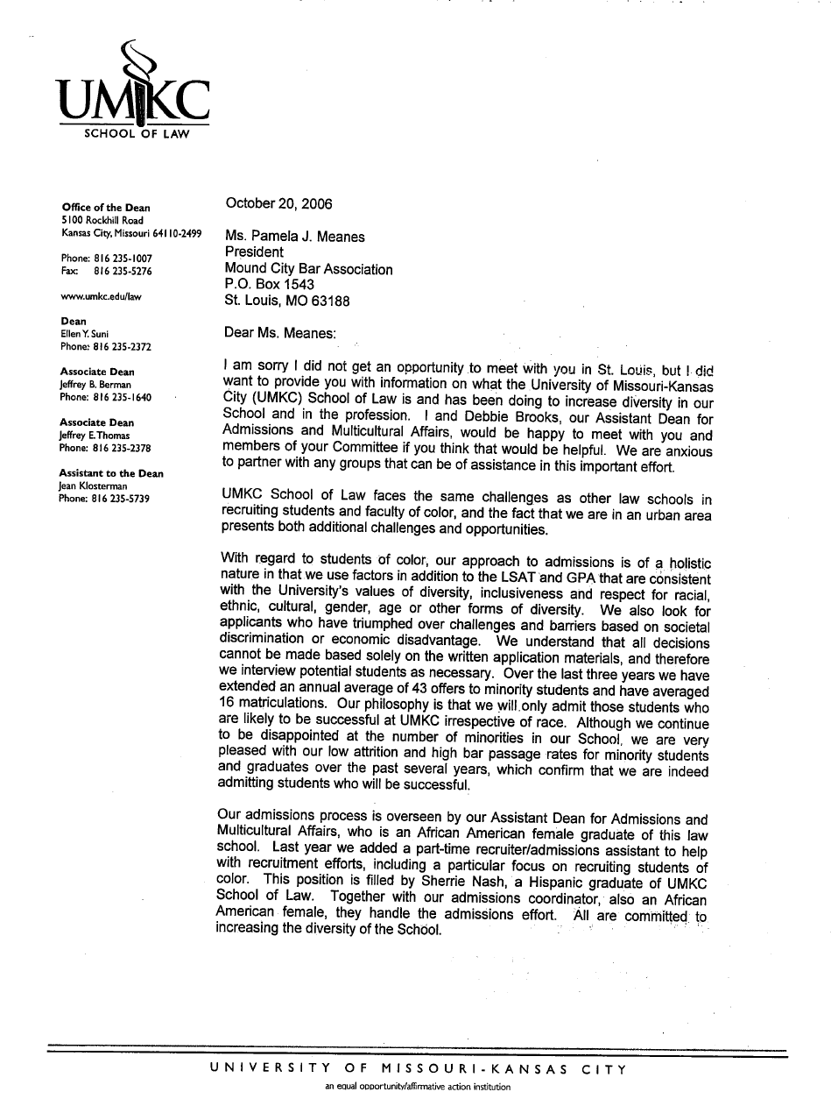
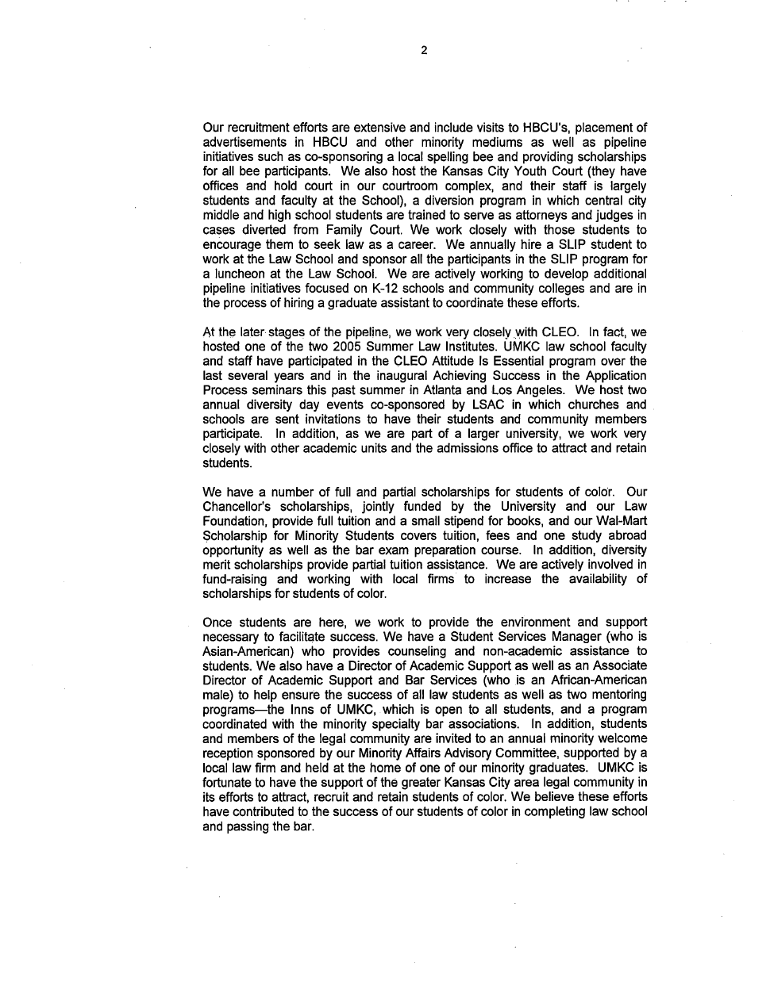
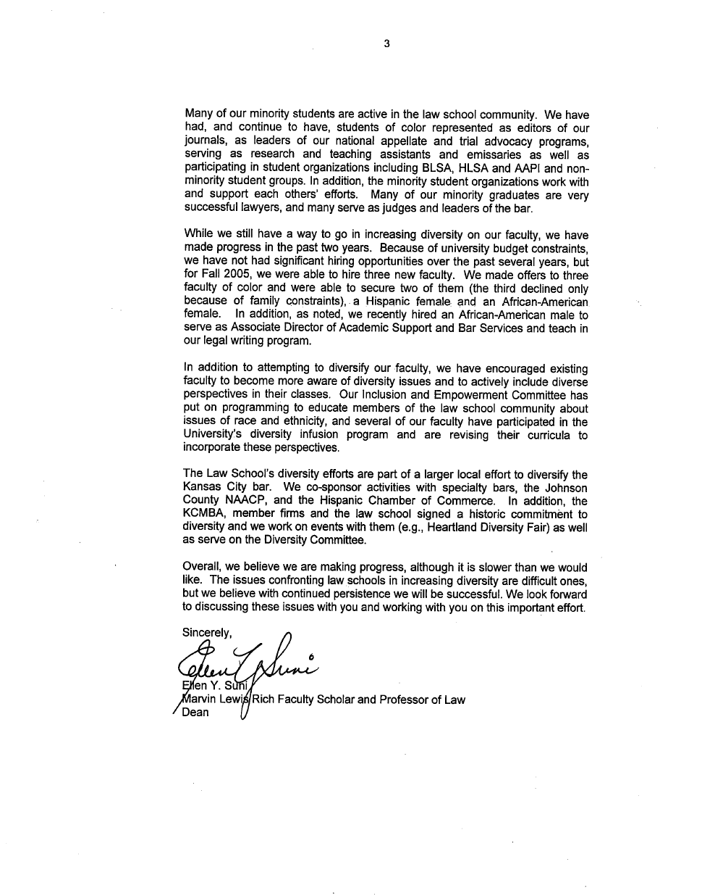

Mound City Bar Association

P.O. Box 1543

St. Louis, MO 63188
Tel: (314) 552-6349

See Reginald M. Turner’s, National Bar Association’s President, May Report on Law School Diversity, available at http://www.nationalbar.org. See also Embracing the Opportunities for Increasing Diversity Into the Legal Profession, Collaborating to Expand the Pipeline (Let’s Get Real), A.B.A. Post-Conference Report, p. 10. The Conference Report is available at http://www.LSACnet.org.
See Reginald M. Turner’s May Report on Law School Diversity, available at http://www.nationalbar.org.
Id.
"illusion." Random House Unabridged Dictionary, © Random House, Inc. 2006.
MCBA made several requests for faculty participation from the University of Missouri – Columbia to serve on the Commission; however, due to many factors, we were unable to obtain a representative. See correspondence in Appendix. Accordingly, participation from MU was limited to an alumnus. Further, due to concerns expressed by law school administrators, the law students were removed from the Commission. Finally, neither the professors nor law students originally on the Commission participated in the drafting of the final report.
See, e.g. Embracing the Opportunities for Increasing Diversity Into the Legal Profession, Collaborating to Expand the Pipeline (Let’s Get Real), A.B.A. Post-Conference Report is available at http://www.LSACnet.org
The Deans of all four Missouri law schools eventually provided information on their respective diversity efforts, after completion of the Commission’s independent research and the Law Students’ Panel. Their letters are reproduced in the Appendix.
AALS Statement of Diversity, Equal Opportunity, and Affirmative Action
Lloyd Gaines, a Missouri citizen, was refused admission to MU Law in 1935 because he was African American. Lincoln University, the State’s only college for the education of African Americans, did not have a law school. The United States Supreme Court held that Mr. Gaines was entitled to be admitted to MU Law in absence of other proper provision for his legal education within the State of Missouri. Unfortunately, Lloyd Gaines mysteriously disappeared shortly after the Supreme Court decision. He never had the opportunity to attend MU Law or any other law school.
Embracing the Opportunities for Increasing Diversity Into the Legal Profession, Collaborating to Expand the Pipeline (Let’s Get Real), A.B.A. Post-Conference Report, available at http://www.LSACnet.org (citing L. Sch. Admis. Council, LSAC Volume Summary by Ethnic and Gender Group (1995-Fall 2005), available at http://www.lsacnet.org.)
A.B.A. Post-Conference Report, supra note 10 (citing A.B.A. Sec. Legal Educ. & Admis. B., Legal Education Statistics, available at http://www.abanet.org/legaled/statistics/minstats.html).
Id.
A.B.A. Post-Conference Report, supra note 10 (citing Gita Z. Wilder, The Road to Law School and Beyond: Examining Challenges to Racial and Ethnic Diversity in the Legal Profession 21 (2003), available at http://www. Lsacnet.org (click on “Research Reports”).
A.B.A. Post-Conference Report, supra note 10 (citing A.B.A. Pres. Advisory Council Diversity Prof., The Critical Need to Further Diversify the Legal Academy and the Legal Profession 5 (2005)).
Adam Liptak, For Blacks in Law School, Can Less Be More?, The New York Times, February 13, 2005.
A.B.A. Post-Conference Report, supra note 10 (citing Judith N. Collins, Jobs for New Law Graduates – Trends from 1994-2004, NALP Bulletin, July 2005, available at http://www.nalp.org/assets/library/82_050divdem.pdf).
More recommendations may be added to this section.
Embracing the Opportunities for Increasing Diversity Into the Legal Profession, Collaborating to Expand the Pipeline (Let’s Get Real), A.B.A. Post-Conference Report is available at http://www.LSACnet.org
Id. at 19.
Id.
Id.
Id. at 36.
Id.
Id.
Id.
Id.
President’s May Report on Law School Diversity, available at http://www.nationalbar.org
AALS Statement of Diversity, Equal Opportunity, and Affirmative Action

